**CSE-467 - Parallel and Distributed Computing**

**Assignment No 2**

**Objective: Write a program for parallel vector addition by using multithreading.**

The complexity of vector addition is O(N) and the execution time depends on the vector length. In this assignment you will learn how to pass and return values from a thread and how logically work can be divided into multiple threads to be performed in parallel and reduce total execution time. You need do device some logic for load balancing.

**Submit a word file containing all code, output snapshots and the comparison table and graph.**

**-------------------------------------------------------------------------------------------------------------------------------**

**Input:**

1. Vector Length: **N** (to be used to create and initialize 3 vectors)
2. No of Threads: **T**

**Processing:** Determine the execution time of vector addition with various values of T and N given in the table.

T0 = get clock cycle/system time

Perform V1 = V2 + V3 with load balancing among T threads.

T1 = get clock cycle/system time

Time elapsed = T1 – T0

**Output:** Time elapsed - Tables show the comparison

Unit for Time elapsed = seconds

|  |  |  |  |  |  |  |  |  |  |
| --- | --- | --- | --- | --- | --- | --- | --- | --- | --- |
|  |  | N (vector size in thousands) | | | | | | | |
|  |  | 50 | 100 | 150 | 200 | 250 | 300 | 350 | 400 |
| T (no of threads) | 1 | 0.000096 | 0.000100 | 0.000081 | 0.000072 | 0.000145 | 0.000133 | 0.000116 | 0.000126 |
| 5 | 0.000224 | 0.000273 | 0.000317 | 0.000324 | 0.000304 | 0.000337 | 0.000346 | 0.000322 |
| 10 | 0.000277 | 0.000332 | 0.000325 | 0.000383 | 0.000340 | 0.000401 | 0.000527 | 0.000435 |
| 15 | 0.000752 | 0.000716 | 0.000651 | 0.000795 | 0.000827 | 0.000794 | 0.000763 | 0.000886 |
| 20 | 0.001033 | 0.001070 | 0.001170 | 0.001191 | 0.000866 | 0.000946 | 0.001132 | 0.001074 |
| 25 | 0.001095 | 0.001476 | 0.001009 | 0.001192 | 0.001819 | 0.001024 | 0.001190 | 0.001641 |
| 30 | 0.001502 | 0.001587 | 0.001255 | 0.001156 | 0.001470 | 0.001219 | 0.001372 | 0.001499 |

**Draw the Graph for above table.**



**Screenshots of output:**

**N = 50, T = 1**

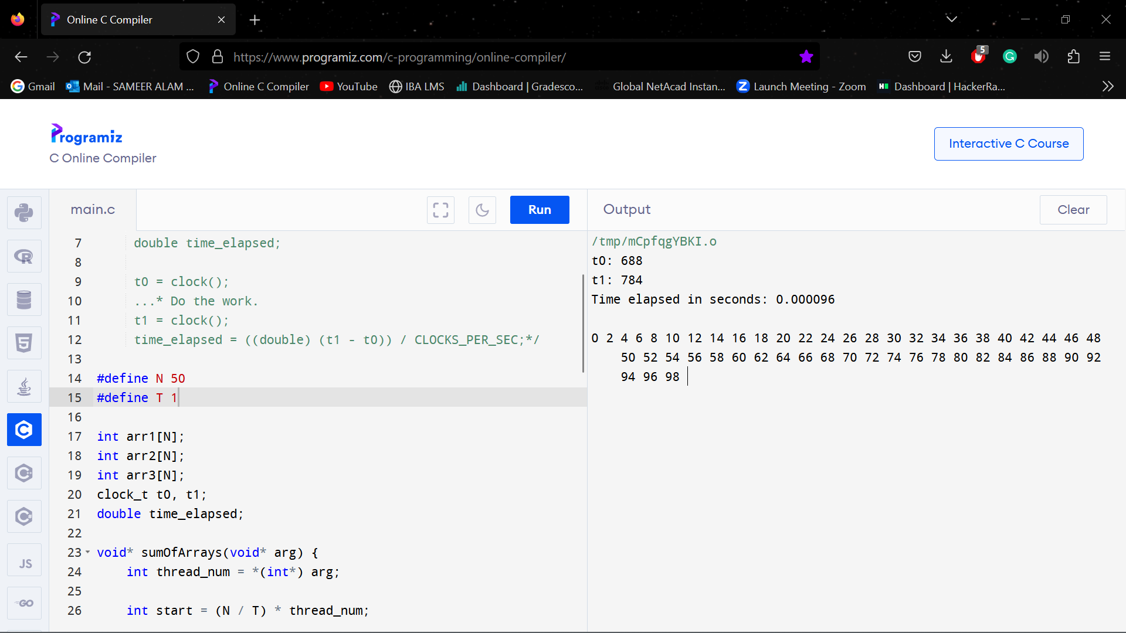

**N = 100, T = 1**

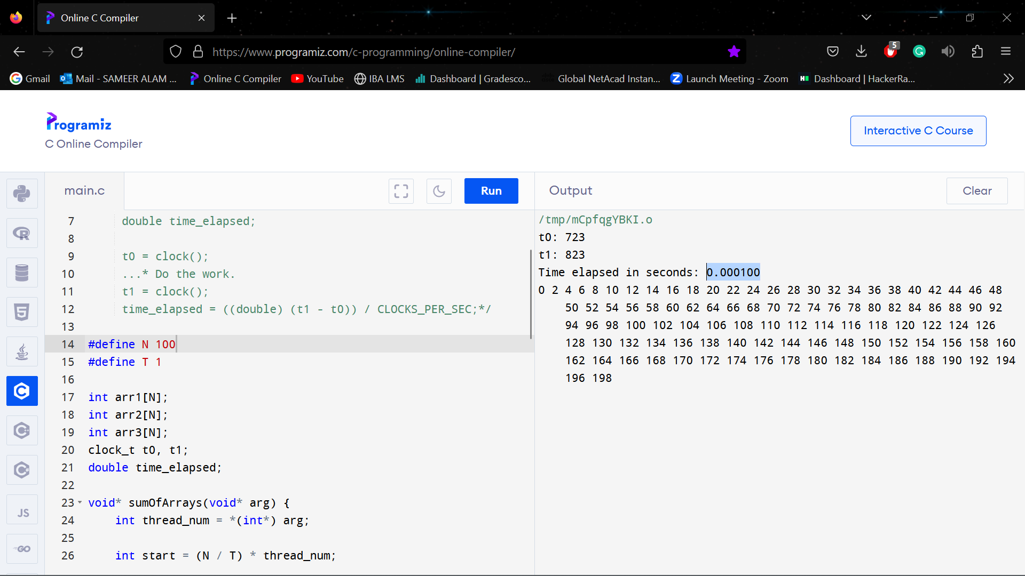

**N = 150, T = 1**

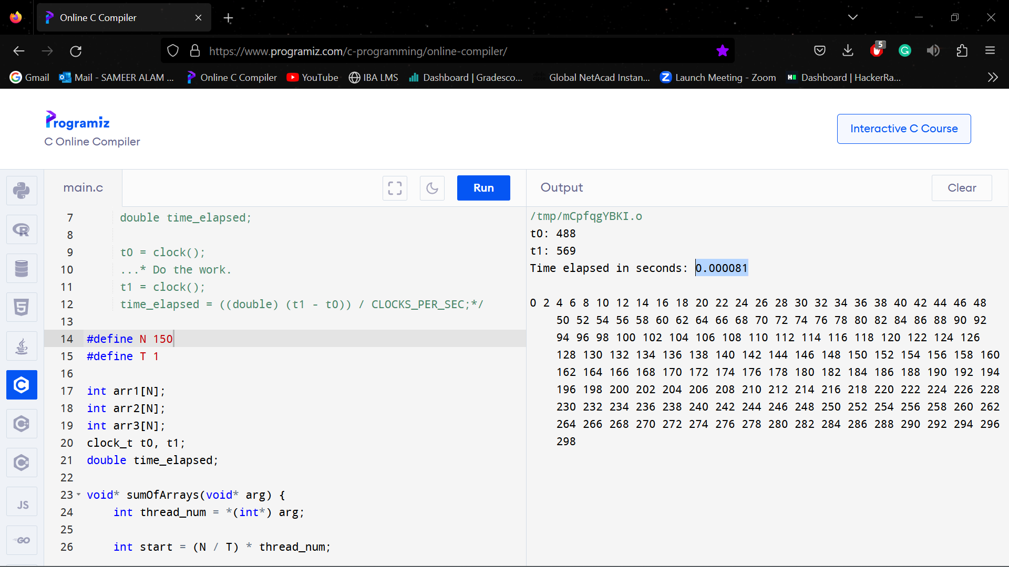

**N = 200, T = 1**

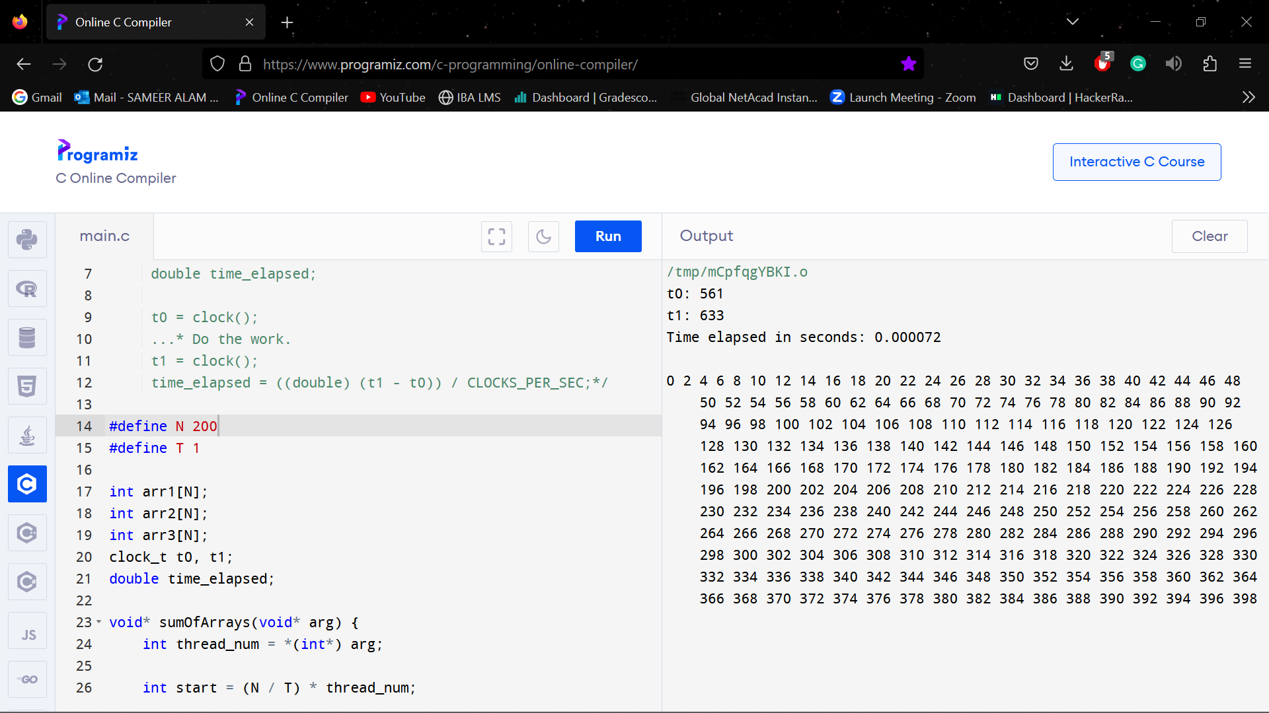

**N = 250, T = 1**

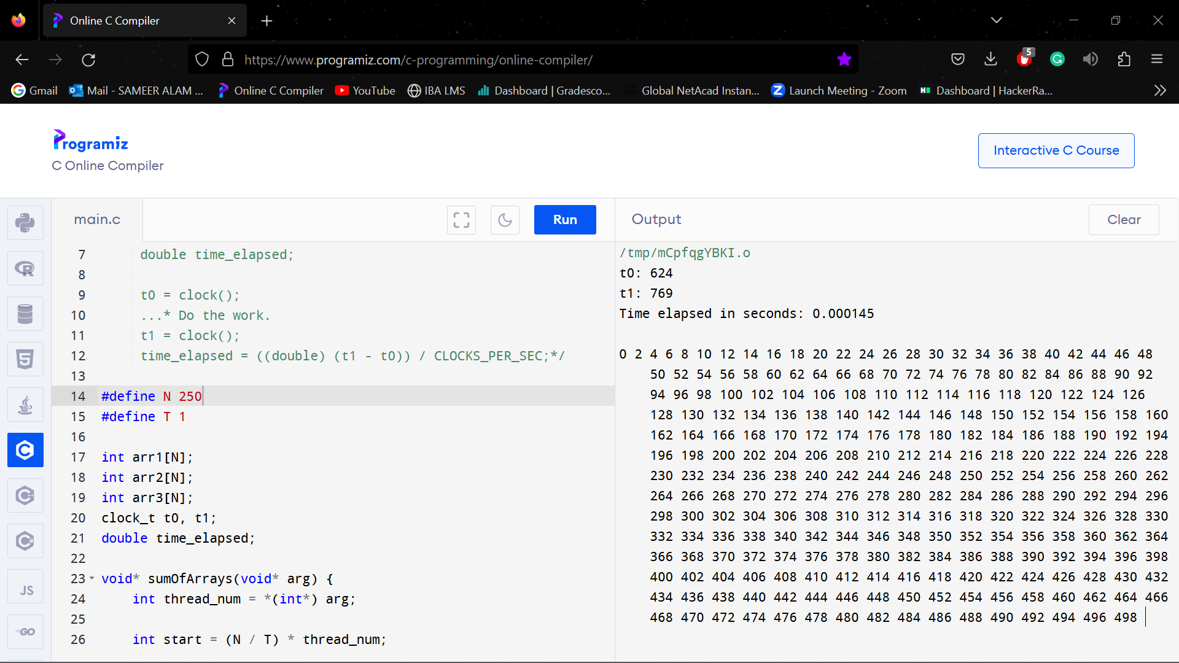

**N = 300, T = 1**

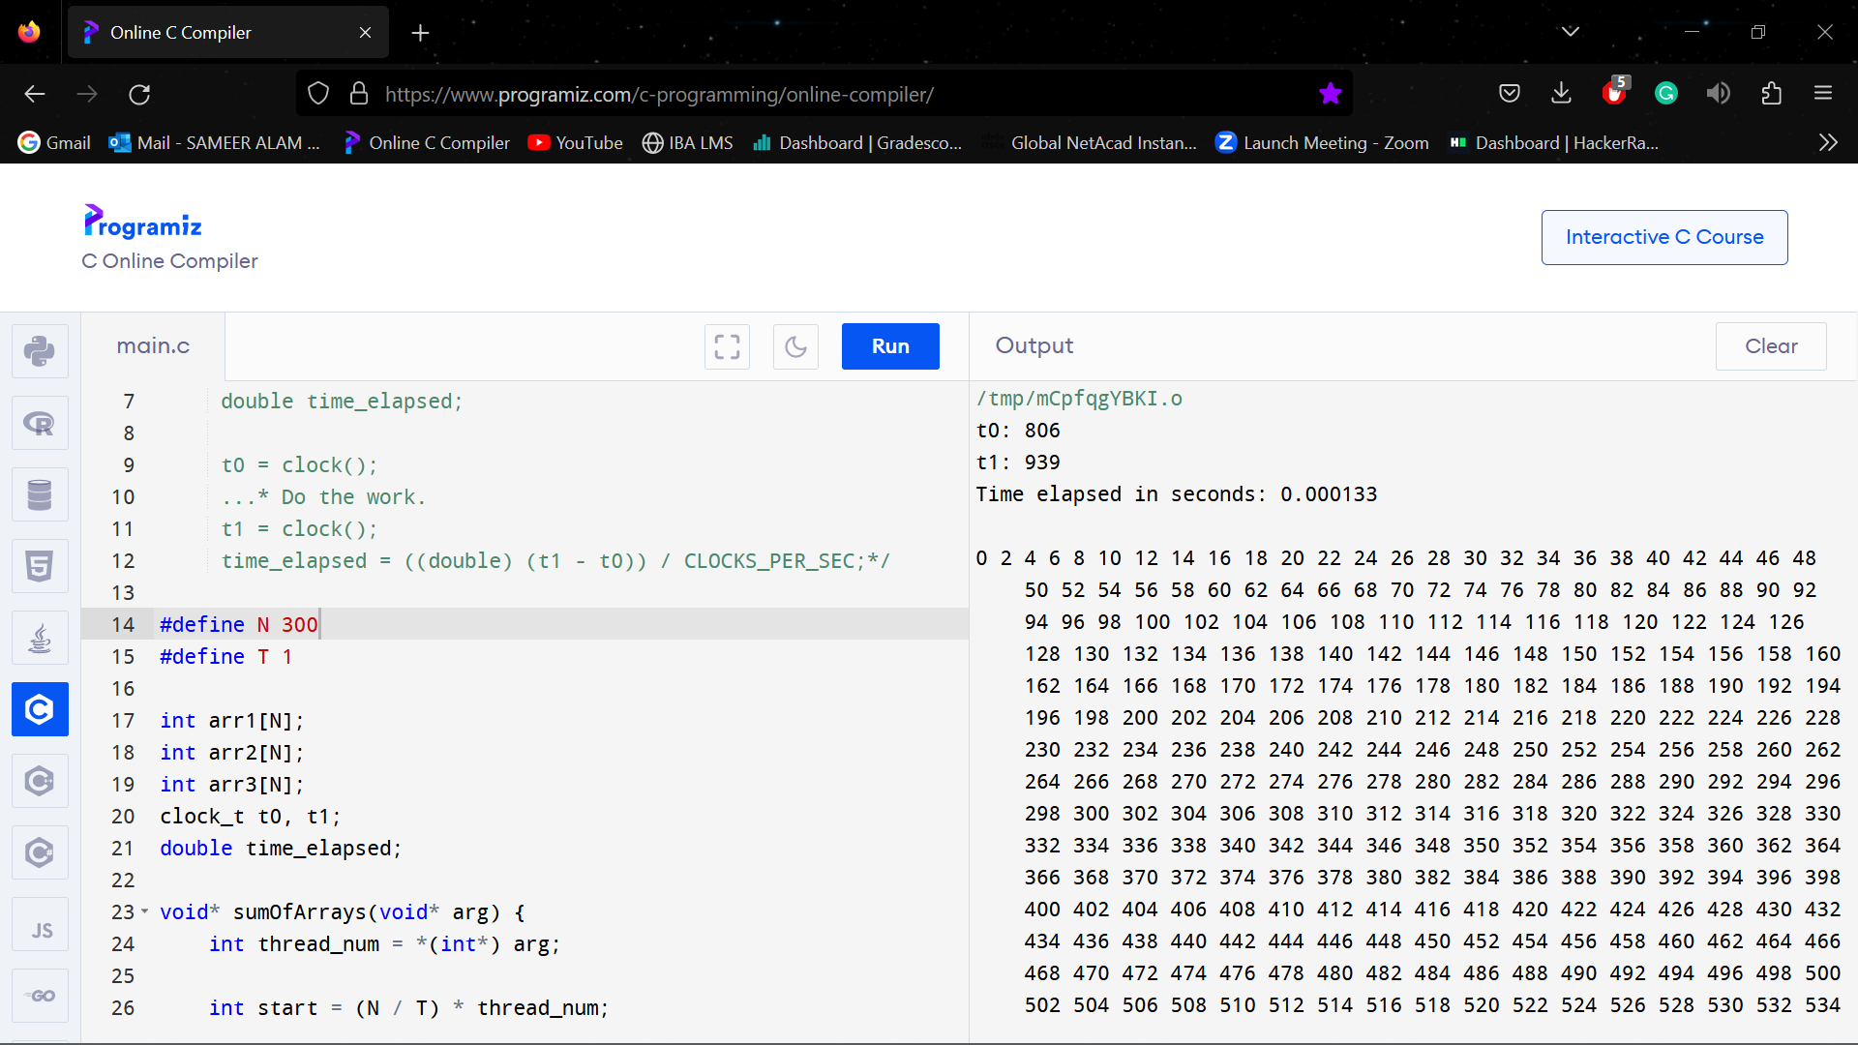

**N = 350, T = 1**

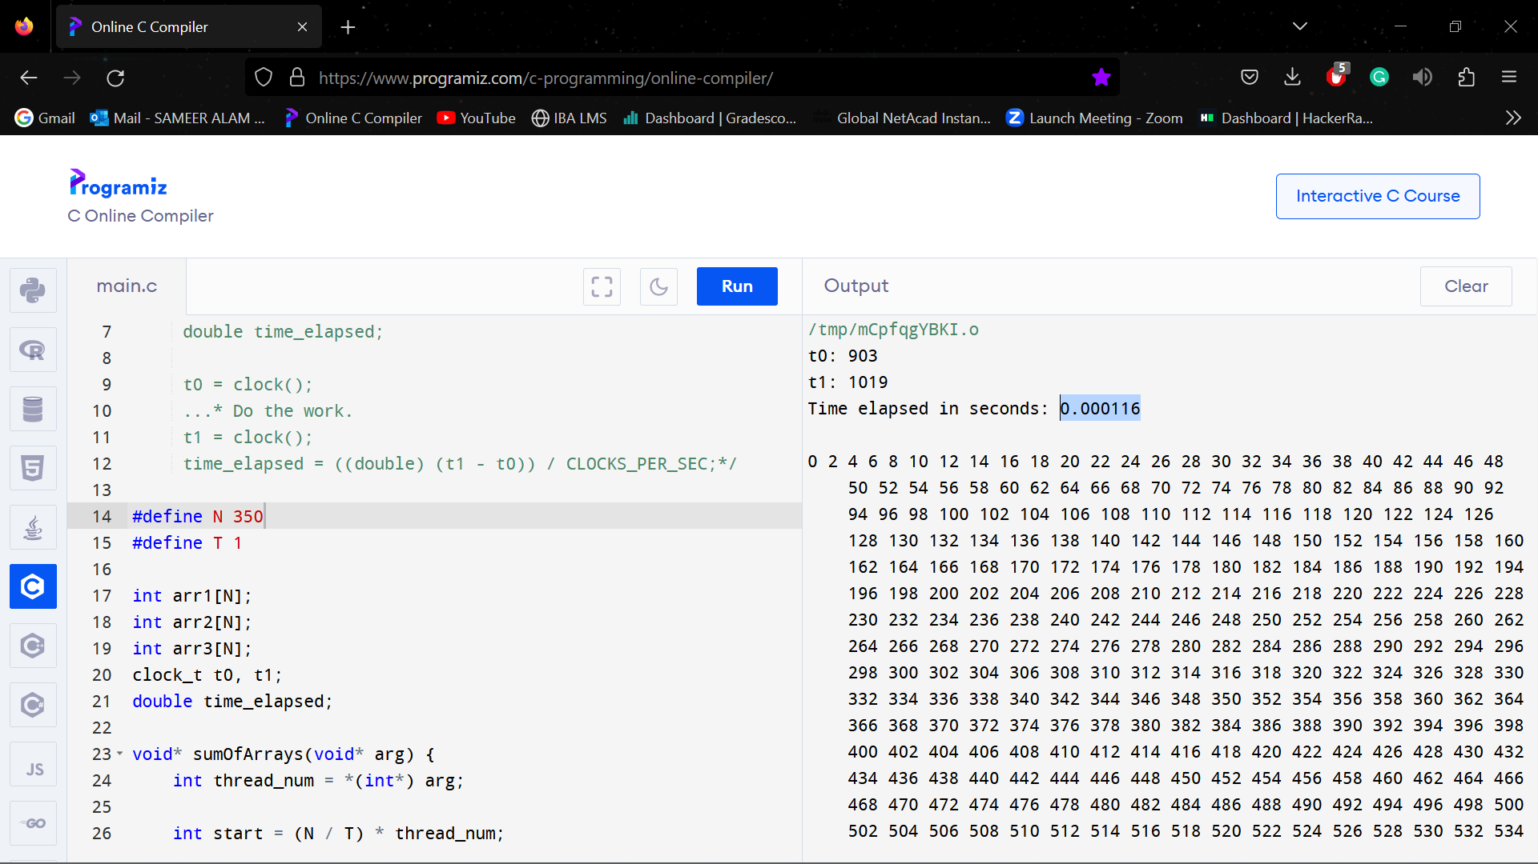

**N = 400, T = 1**

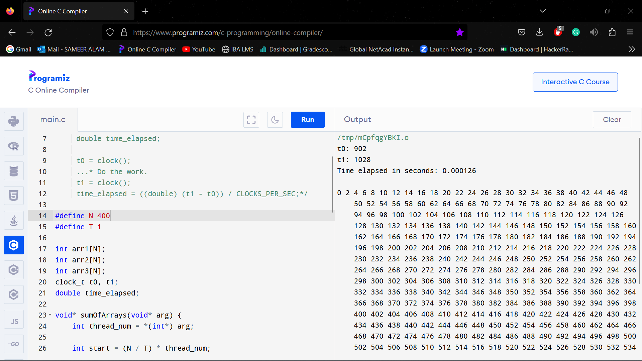

**N = 50, T = 5**

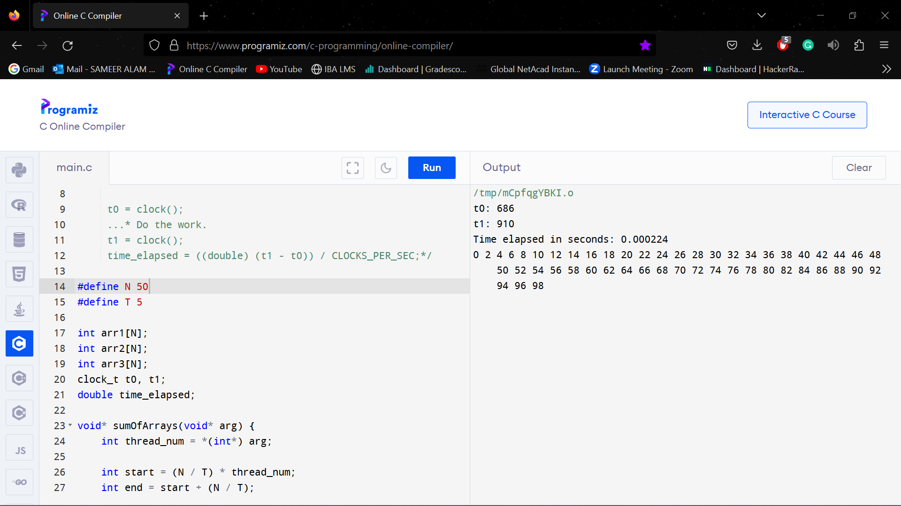

**N = 100, T = 5**

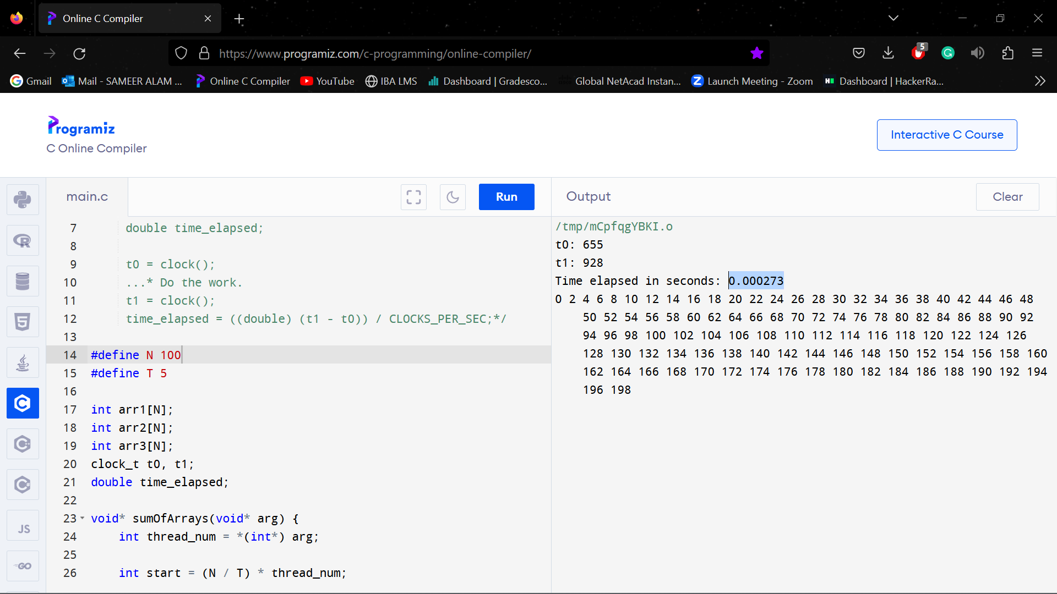

**N = 150, T = 5**

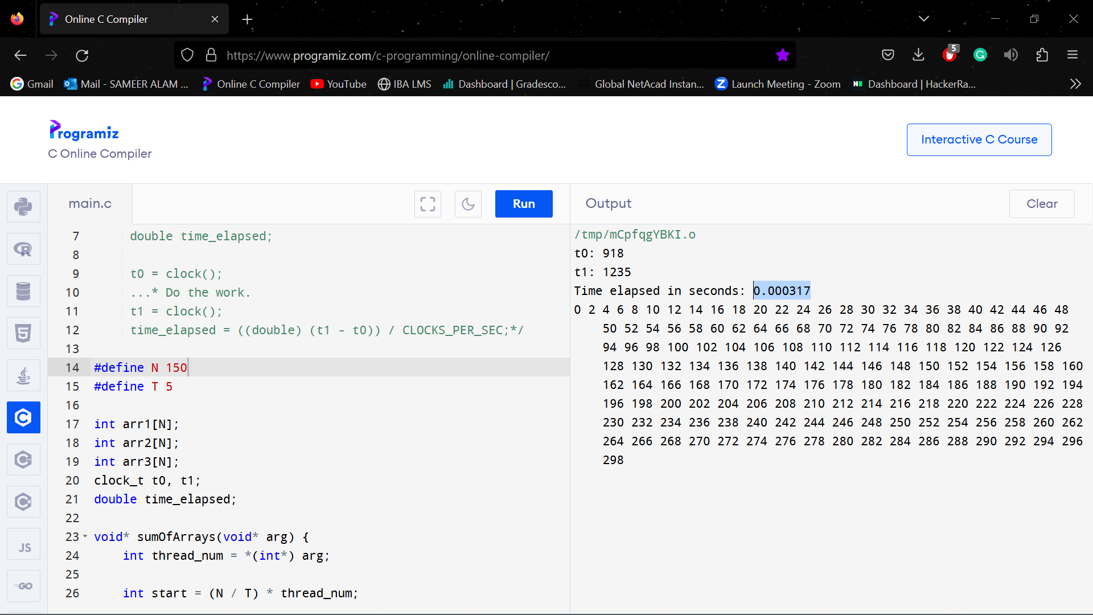

**N = 200, T = 5**

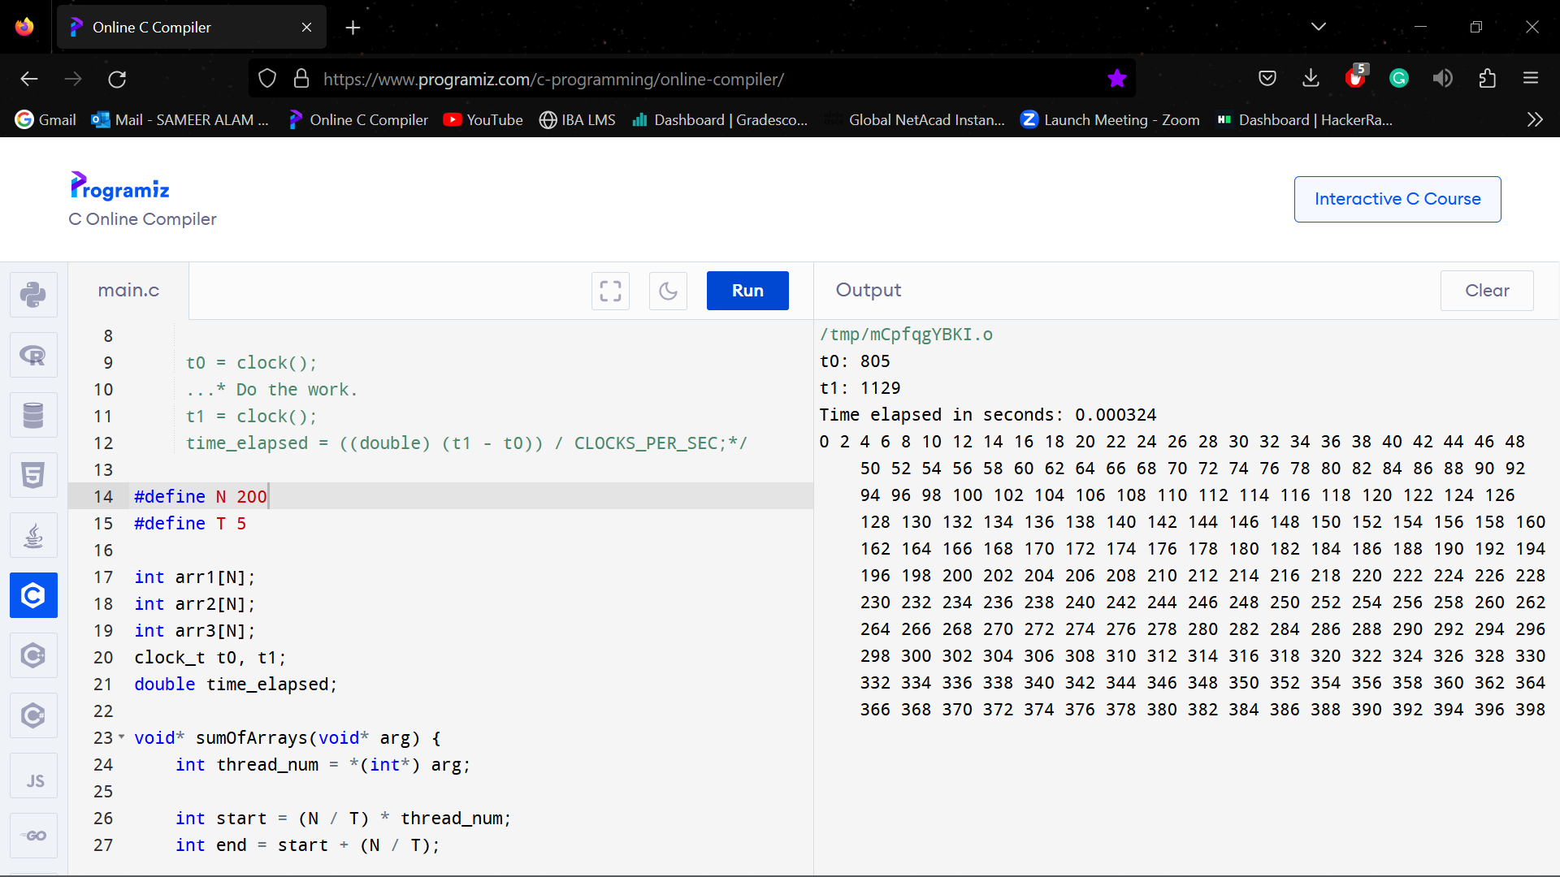

**N = 250, T = 5**

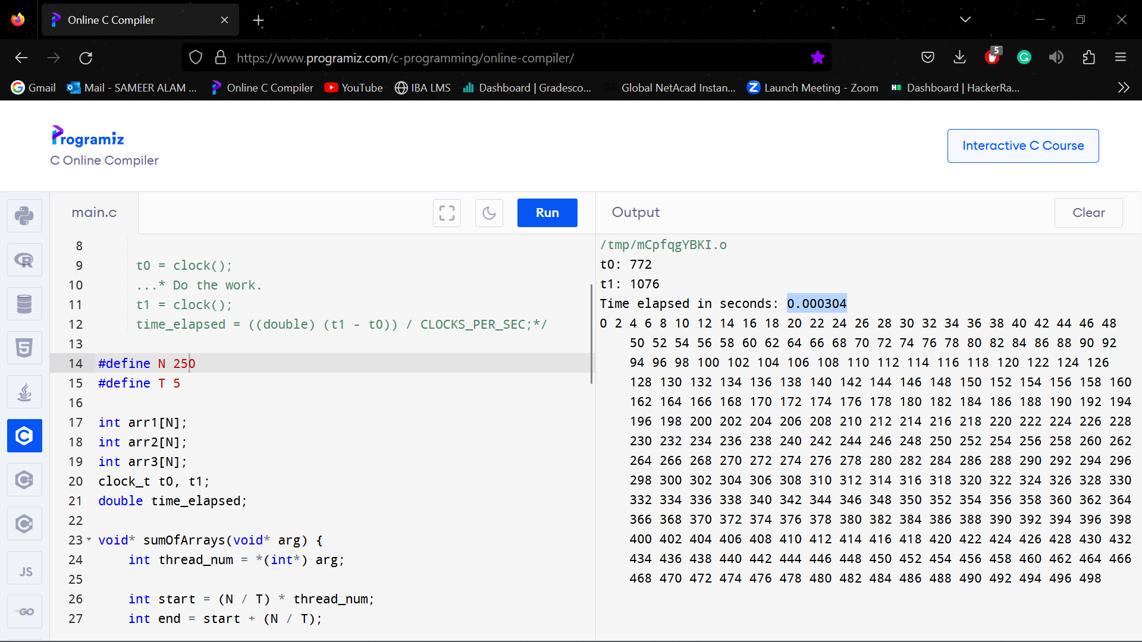

**N = 300, T = 5**

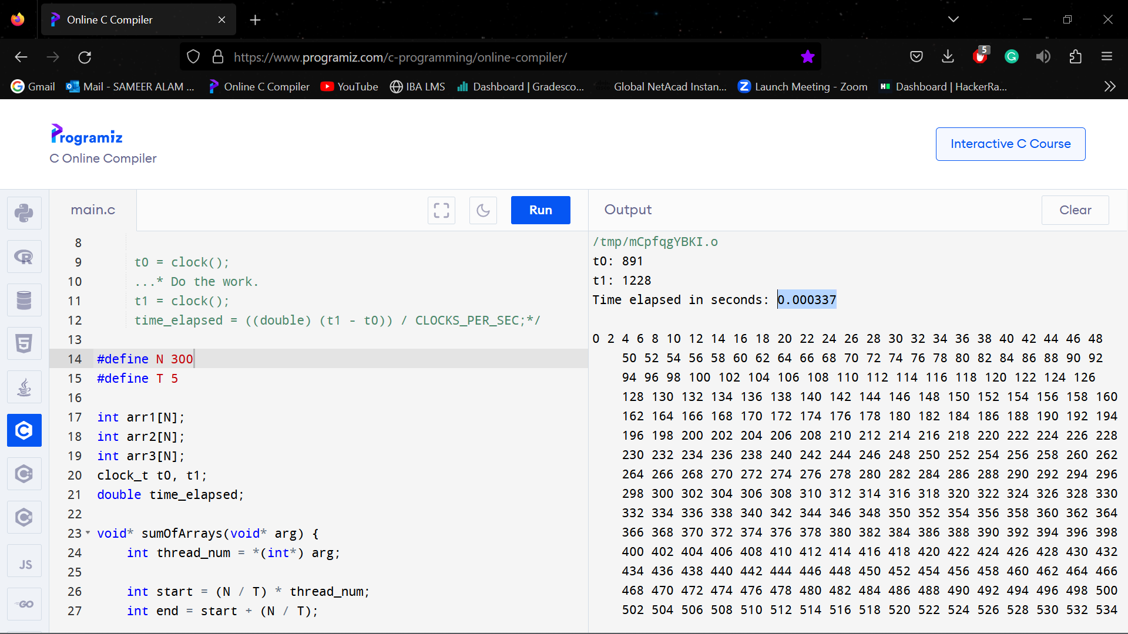

**N = 350, T = 5**

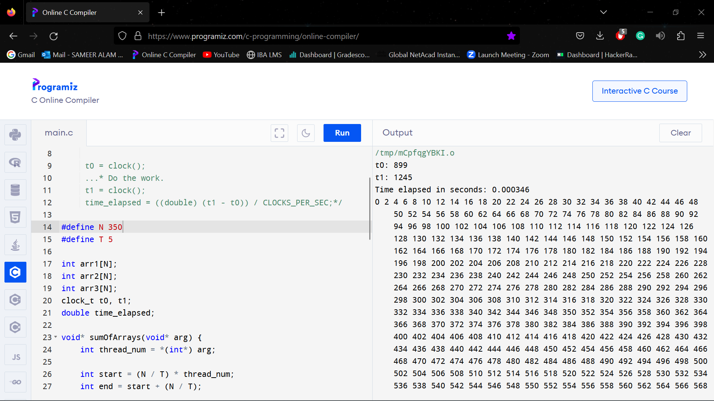

**N = 400, T = 5**

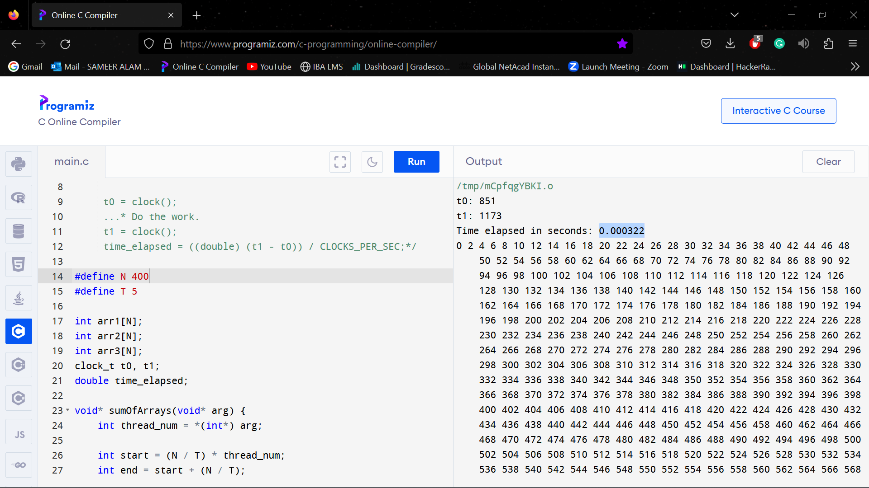

**N = 50, T = 10**

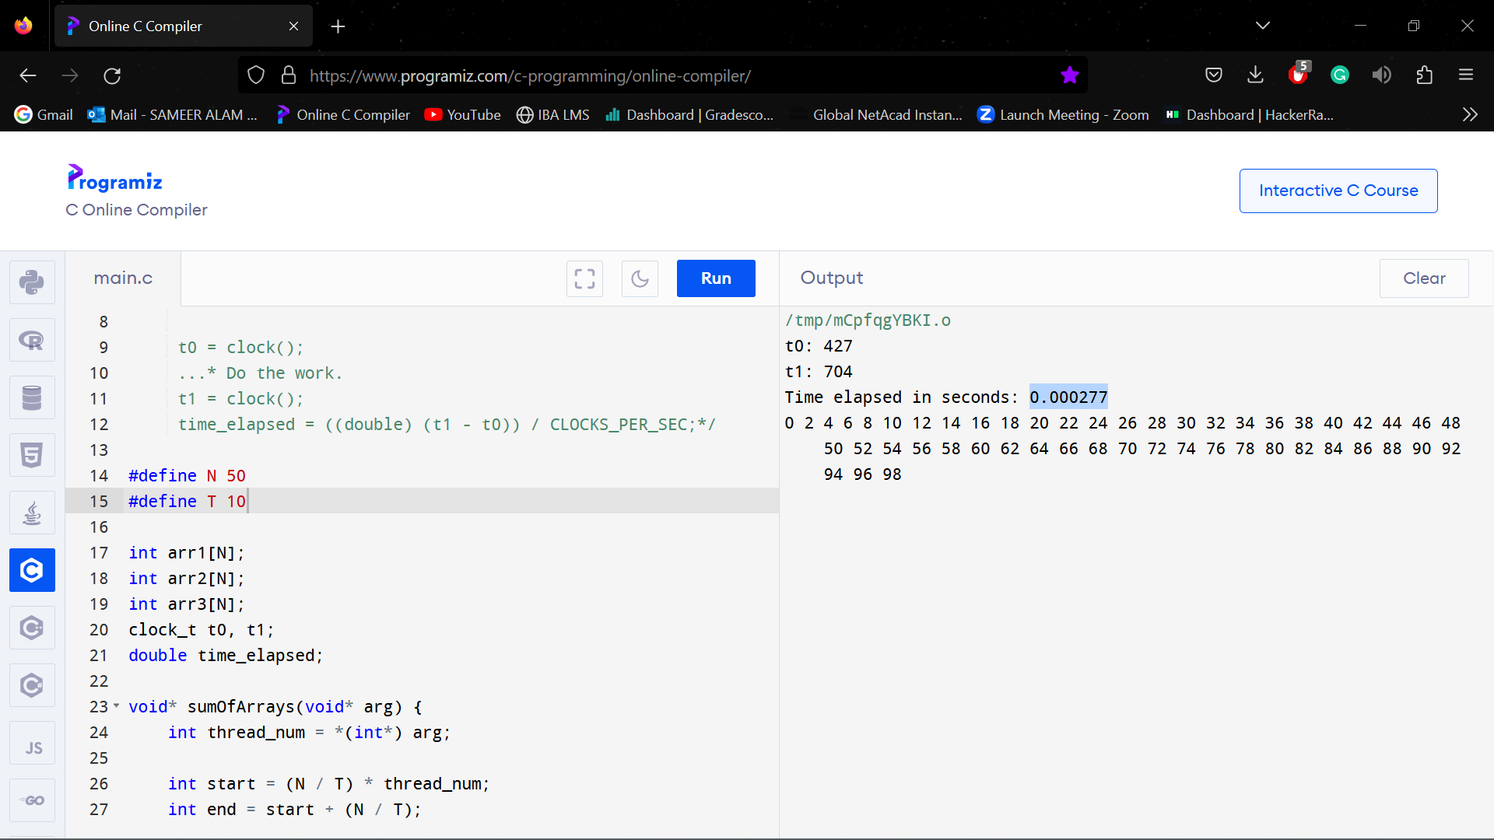

**N = 100, T = 10**

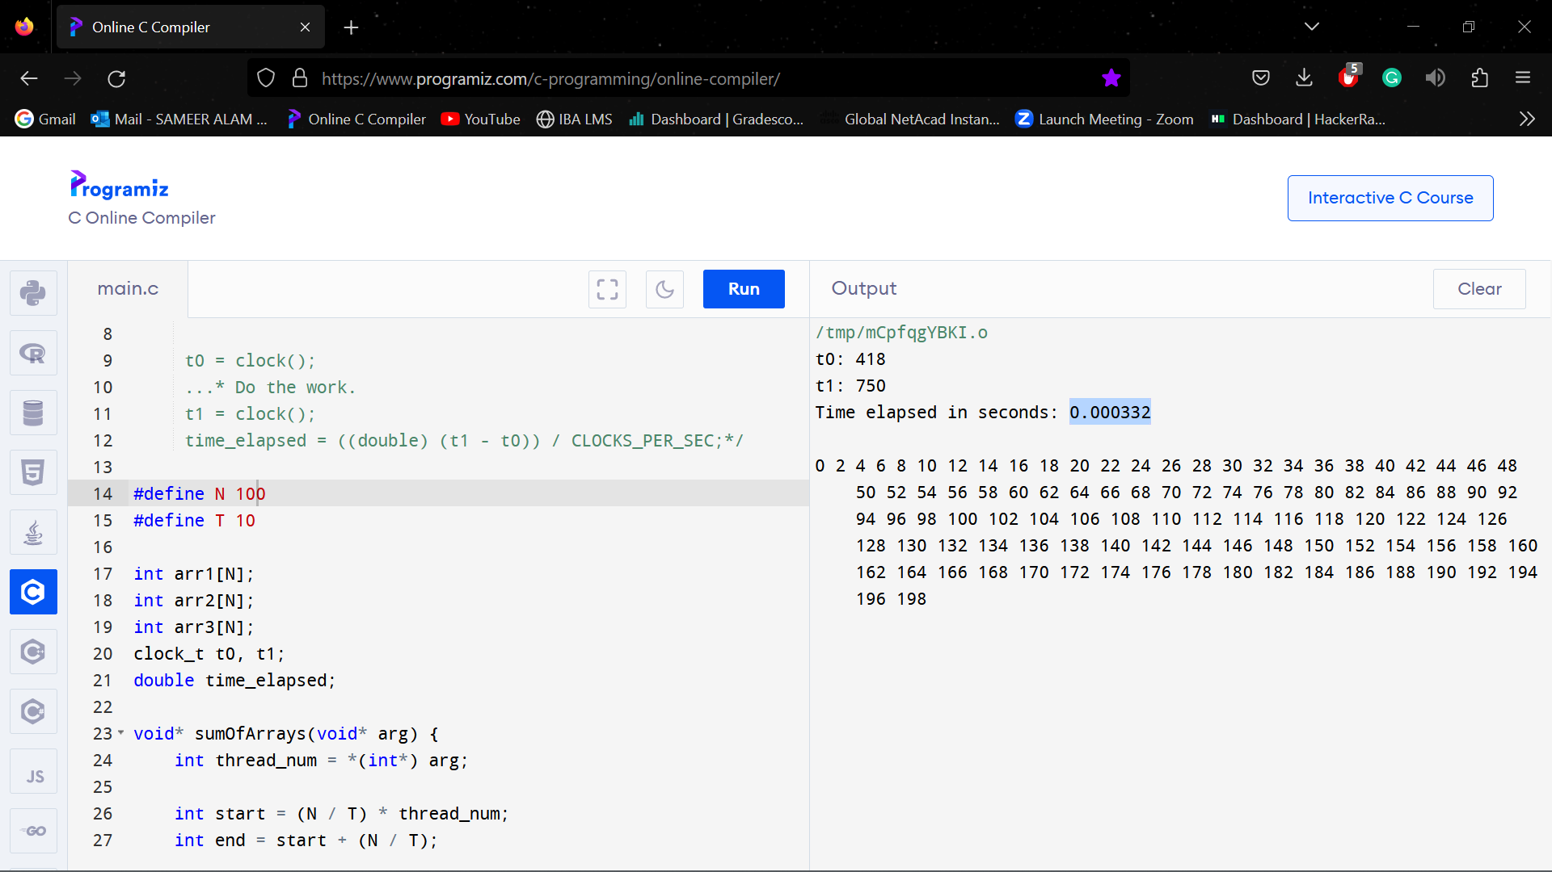

**N = 150, T = 10**

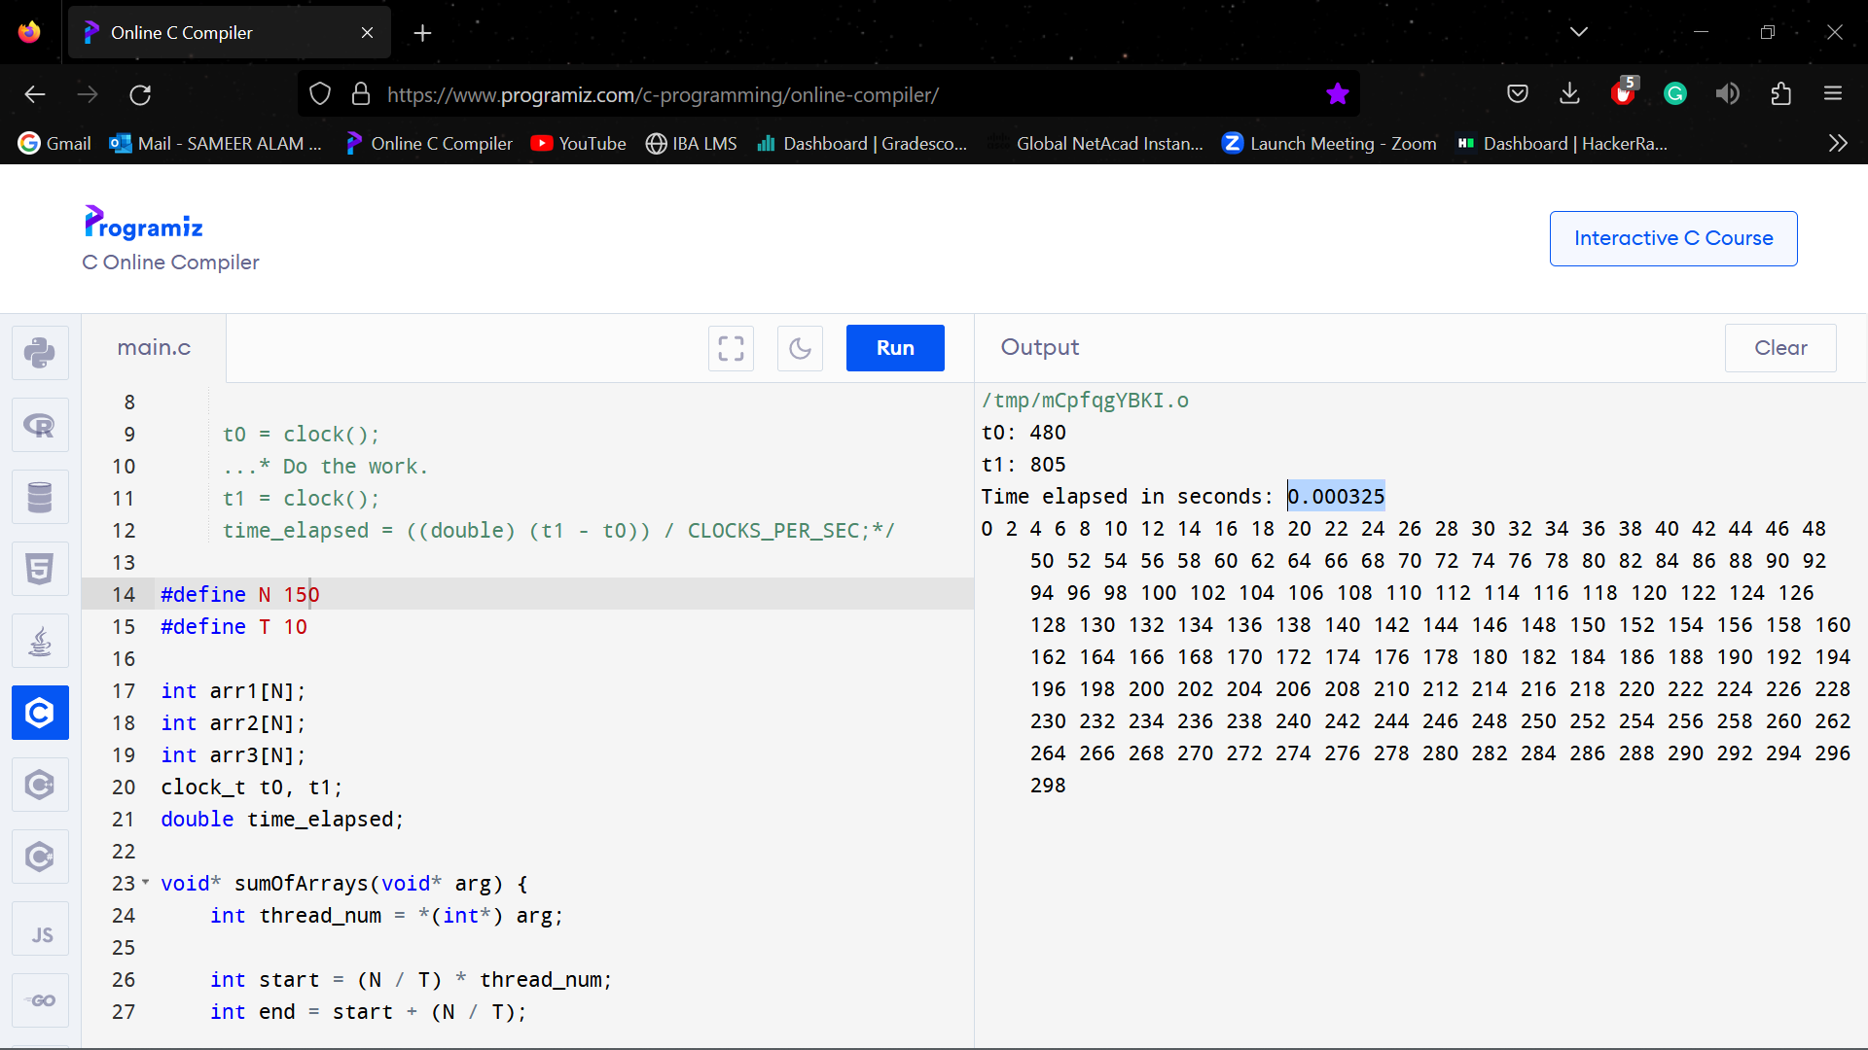

**N = 200, T = 10**

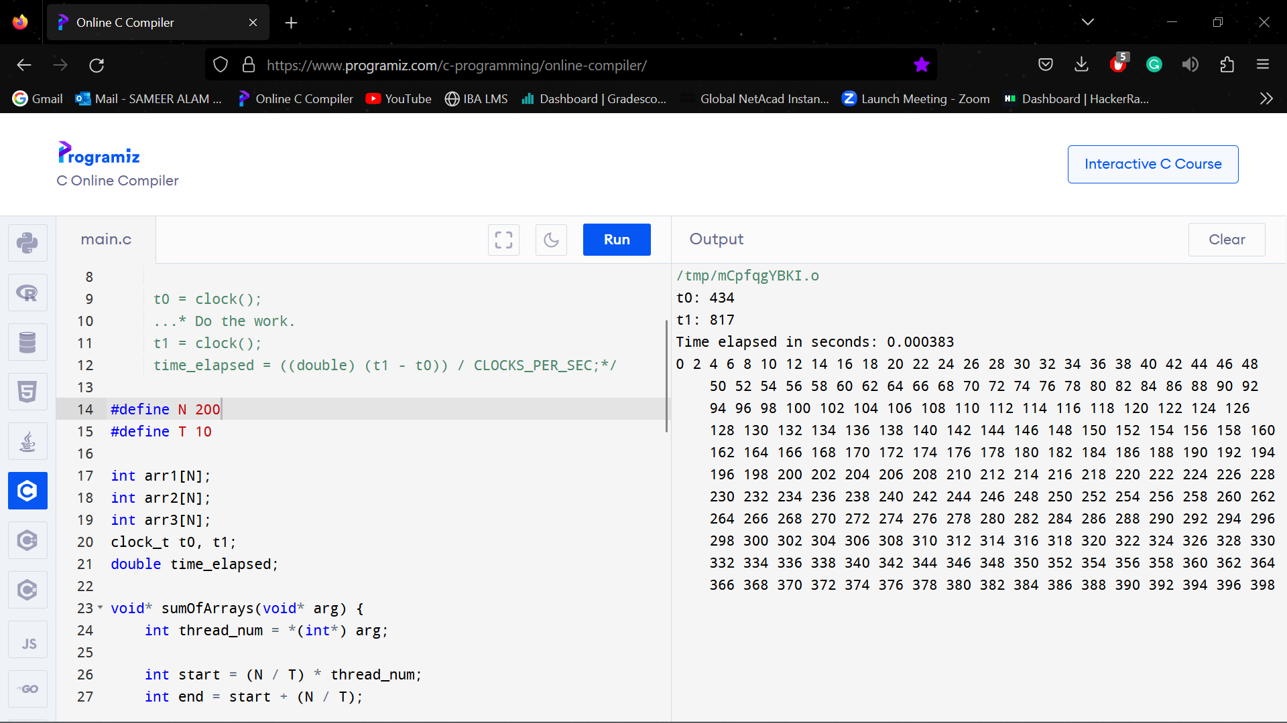

**N = 250, T = 10**

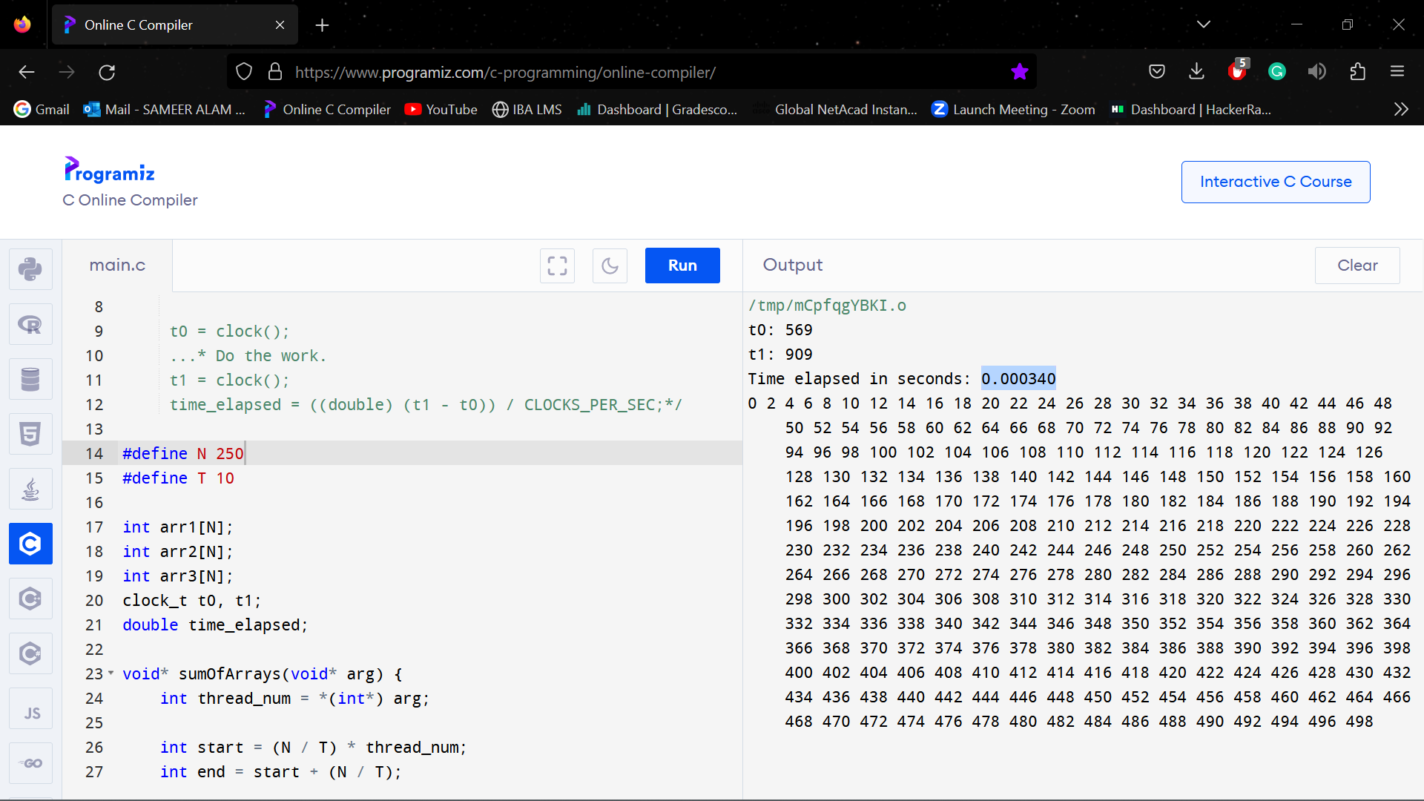

**N = 300, T = 10**

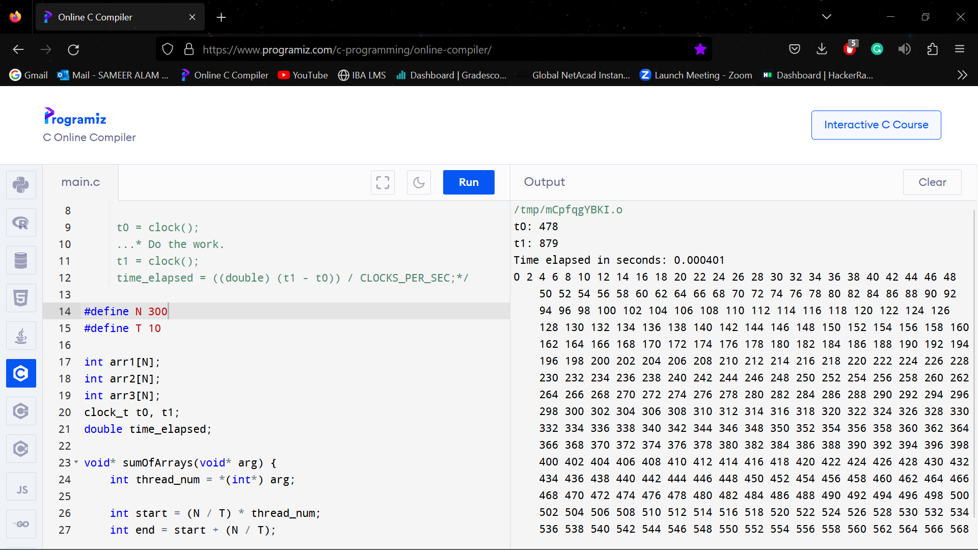

**N = 350, T = 10**

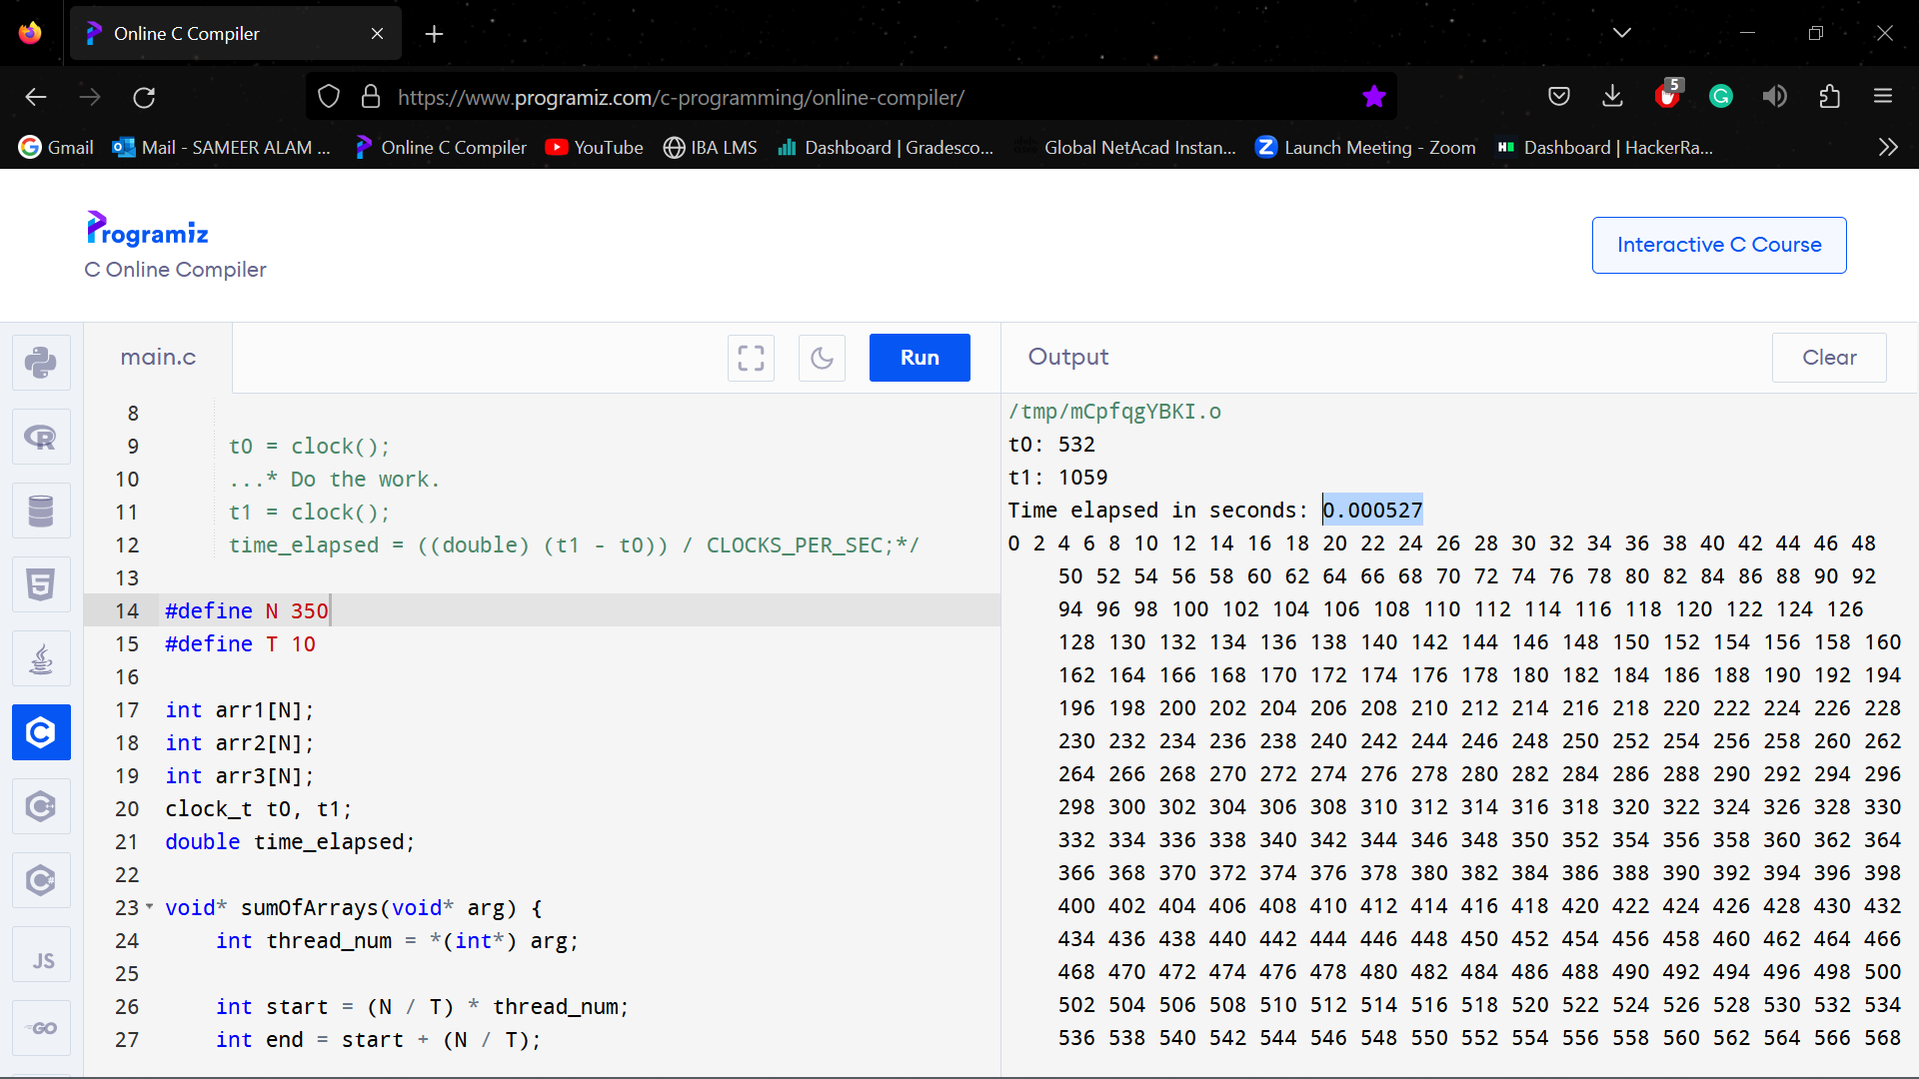

**N = 400, T = 10**

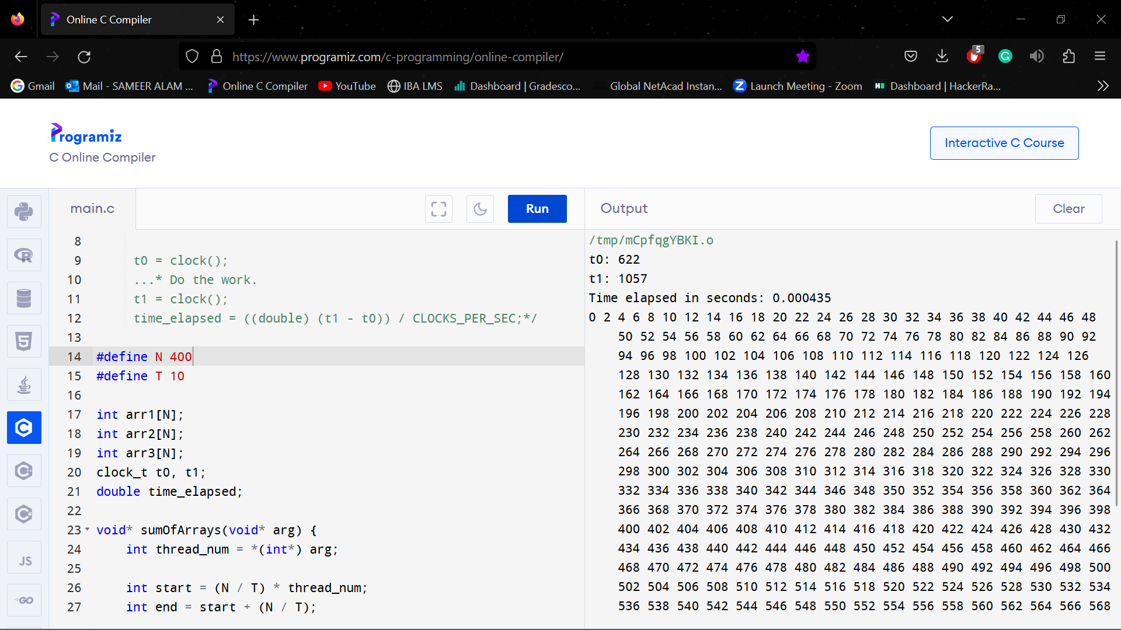

**N = 50, T = 15**

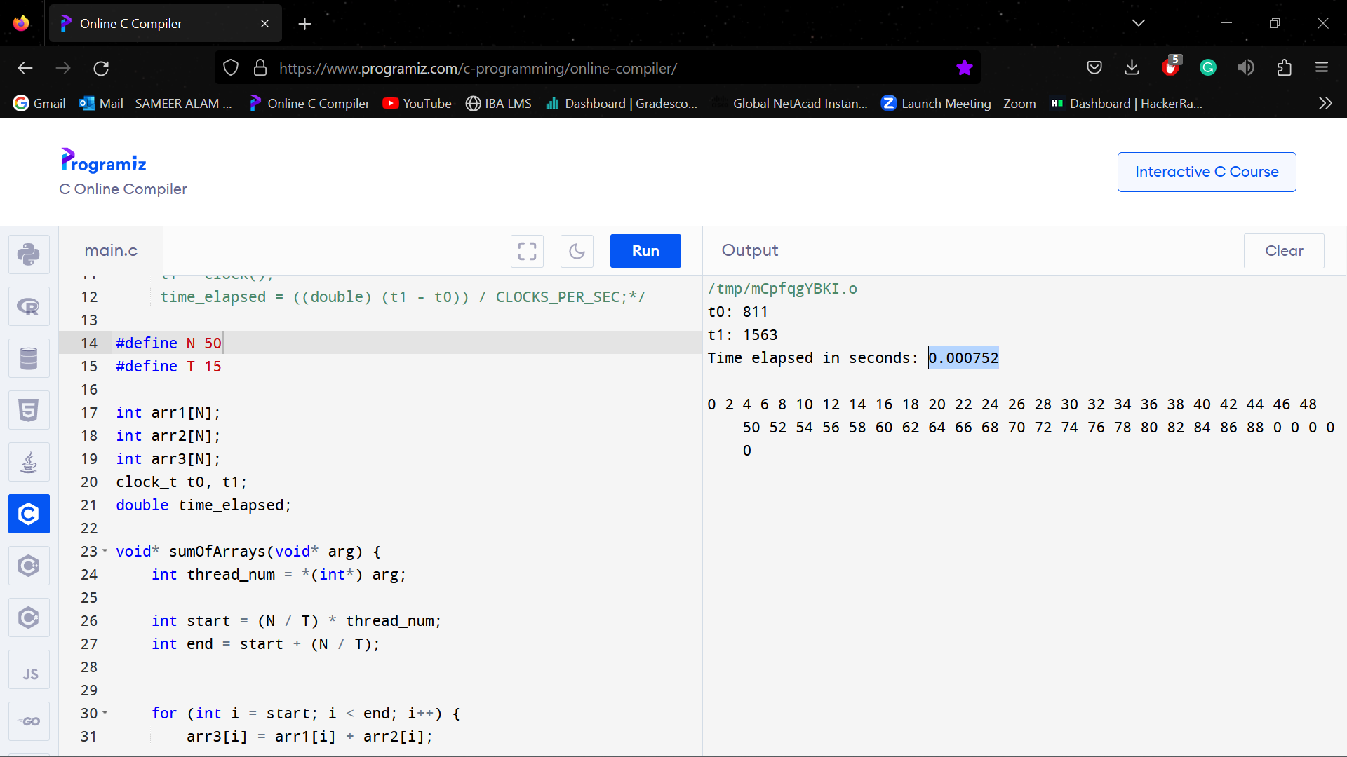

**N = 100, T = 15**

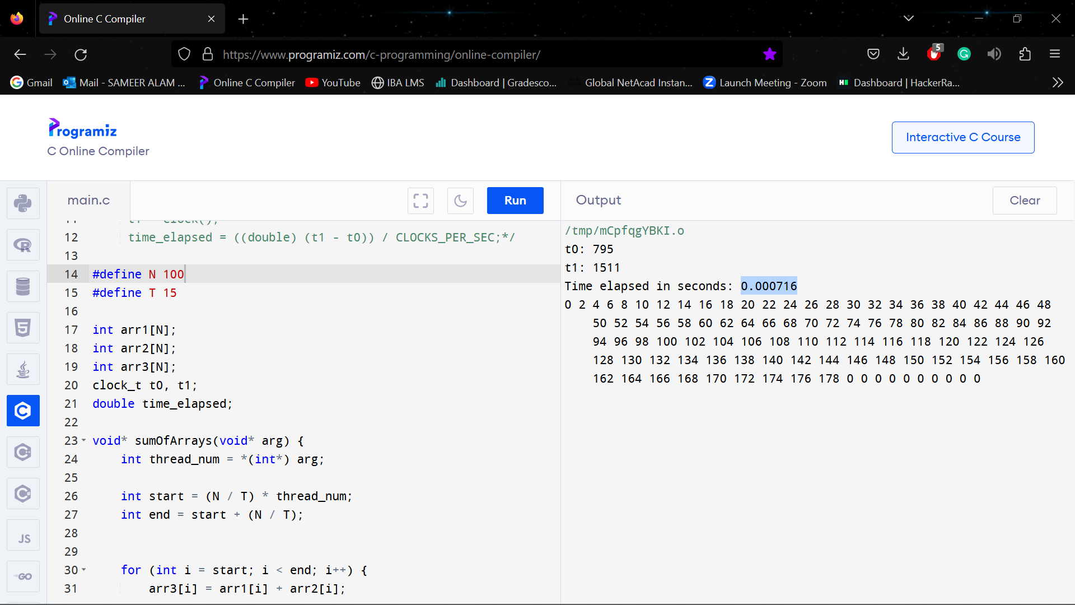

**N = 150, T = 15**

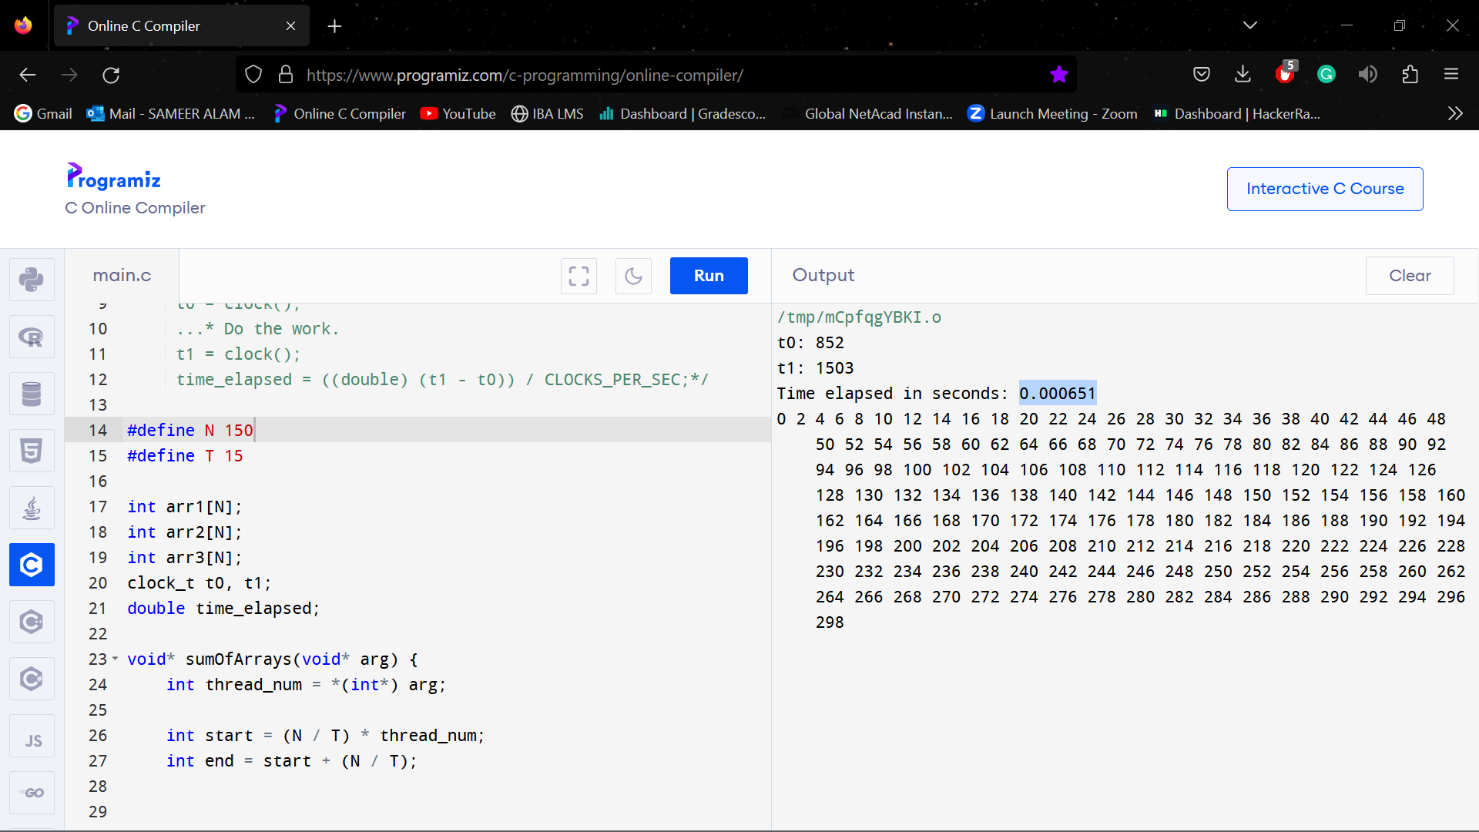

**N = 200, T = 15**

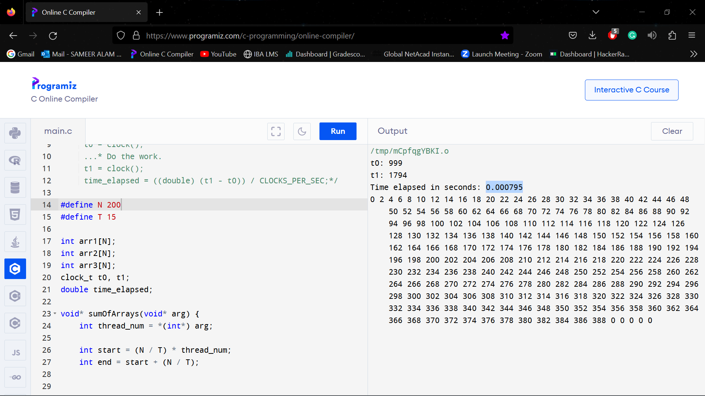

**N = 250, T = 15**

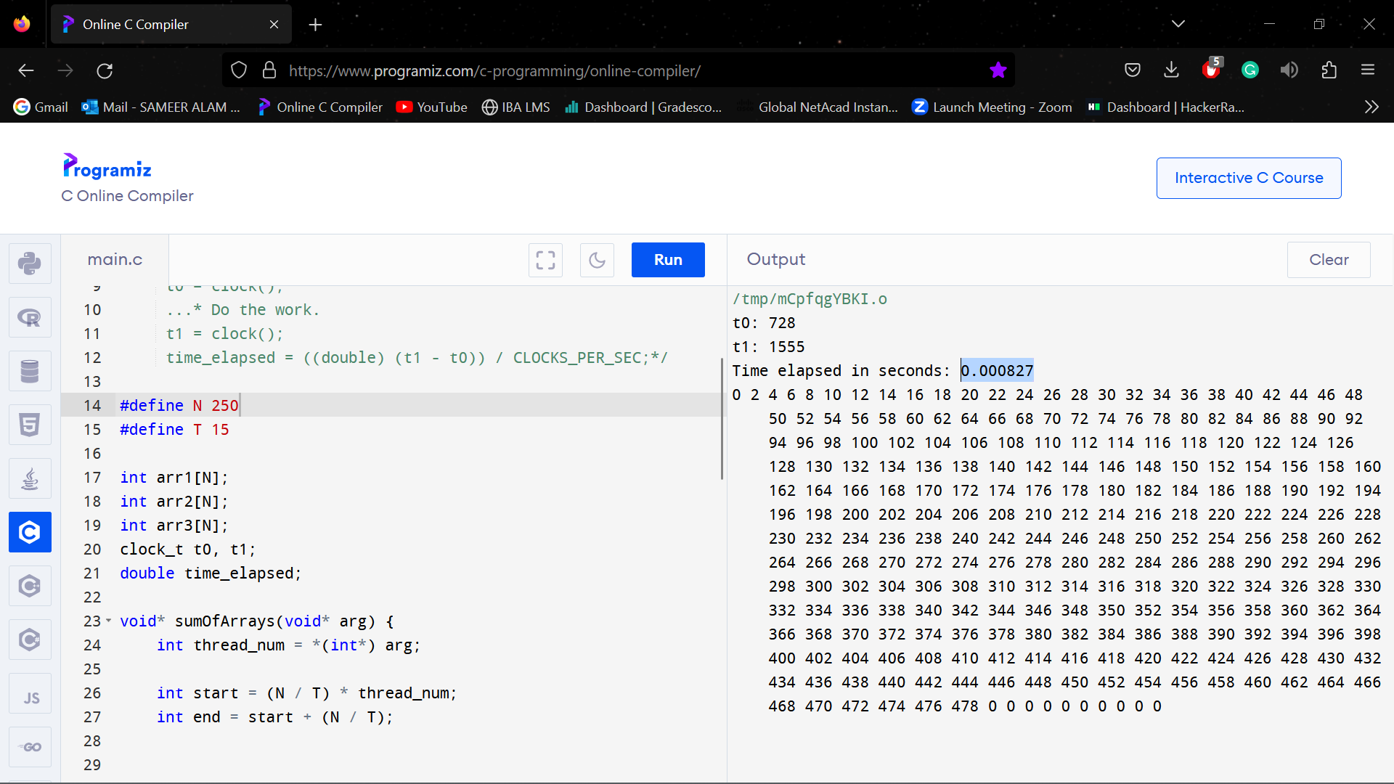

**N = 300, T = 15**

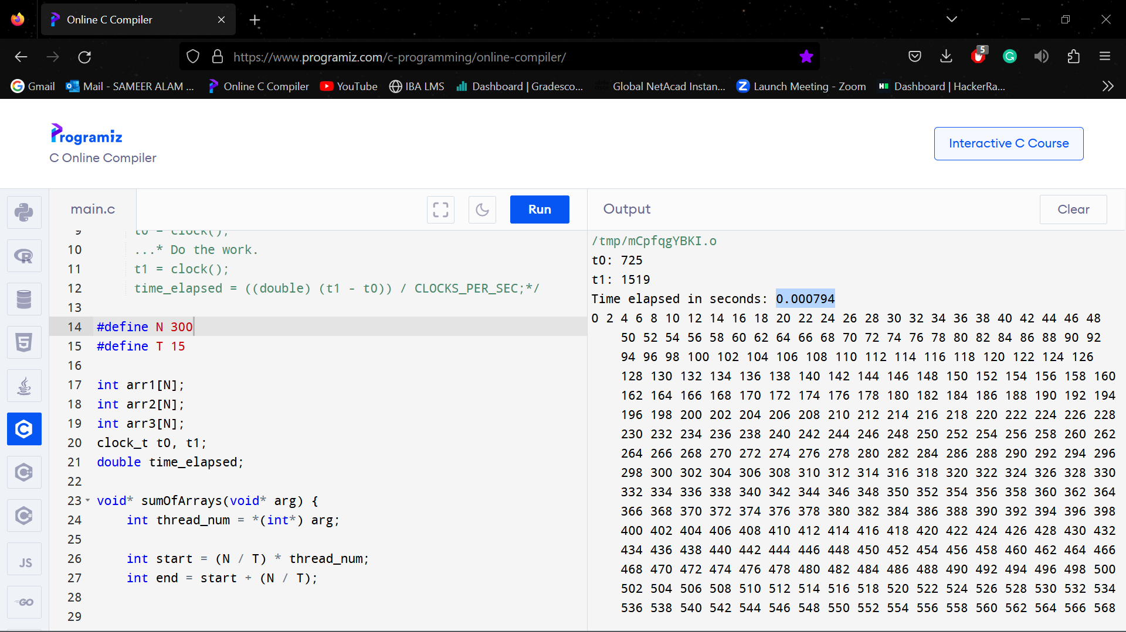

**N = 350, T = 15**

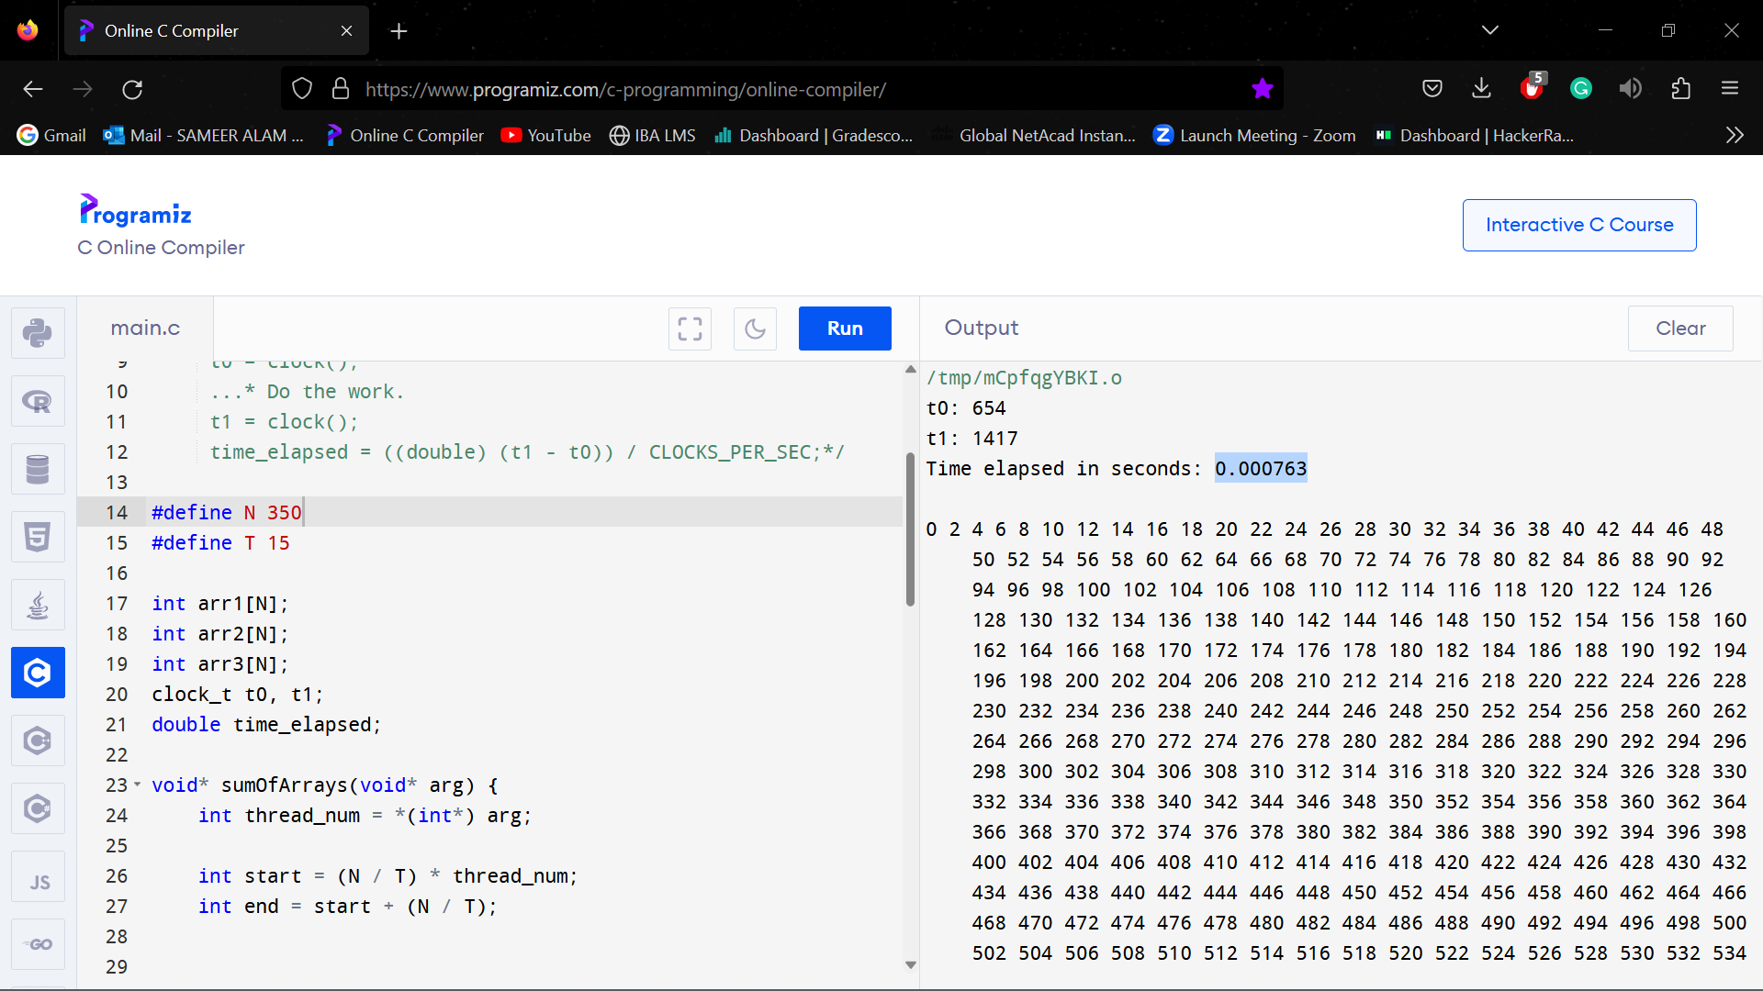

**N = 400, T = 15**

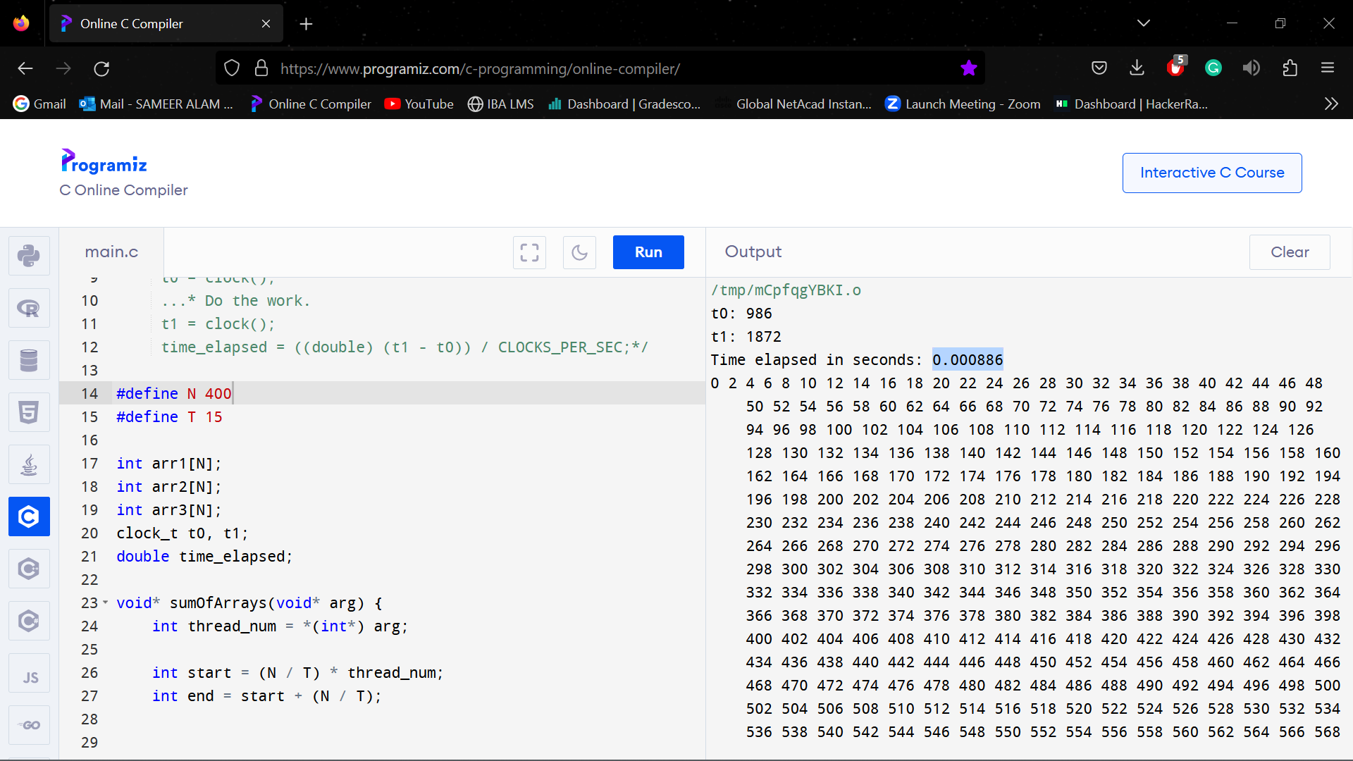

**N = 50, T = 20**

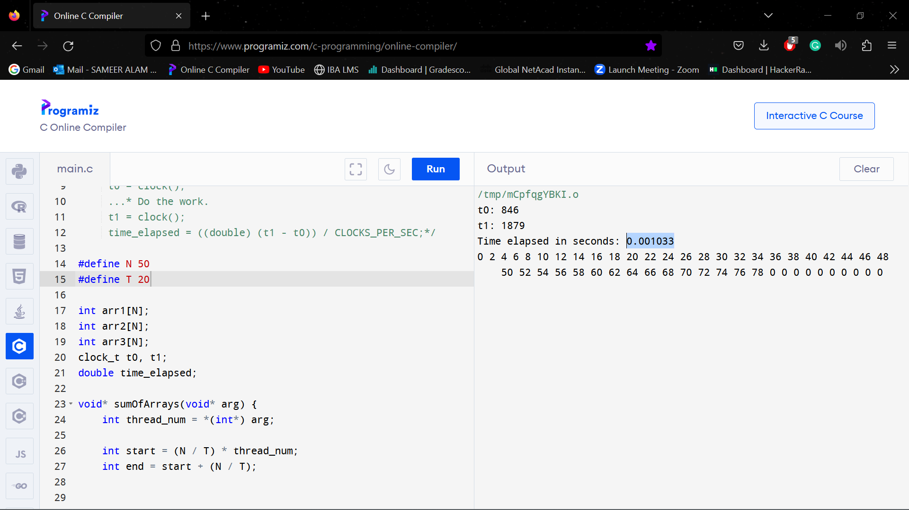

**N = 100, T = 20**

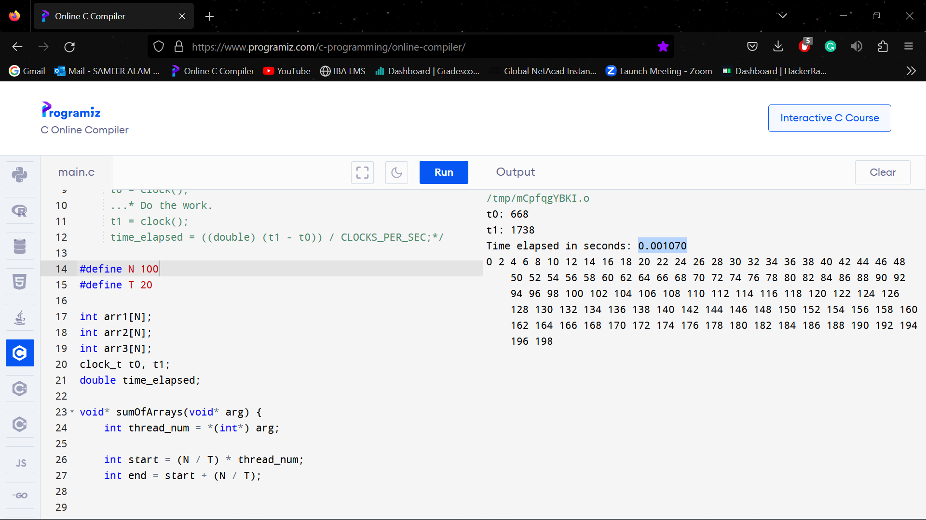

**N = 150, T = 20**

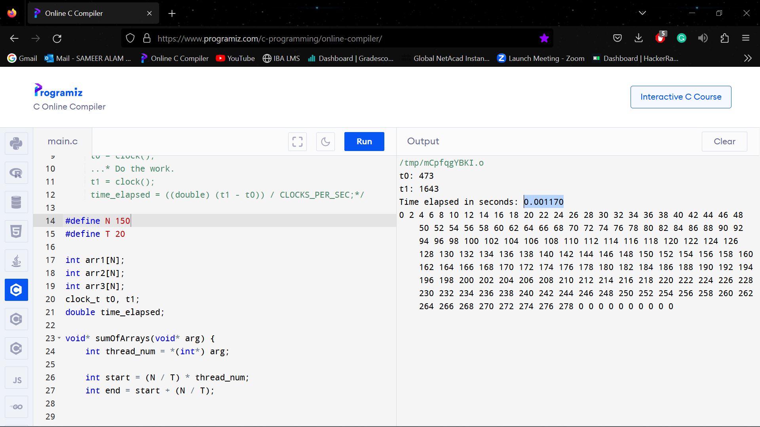

**N = 200, T = 20**

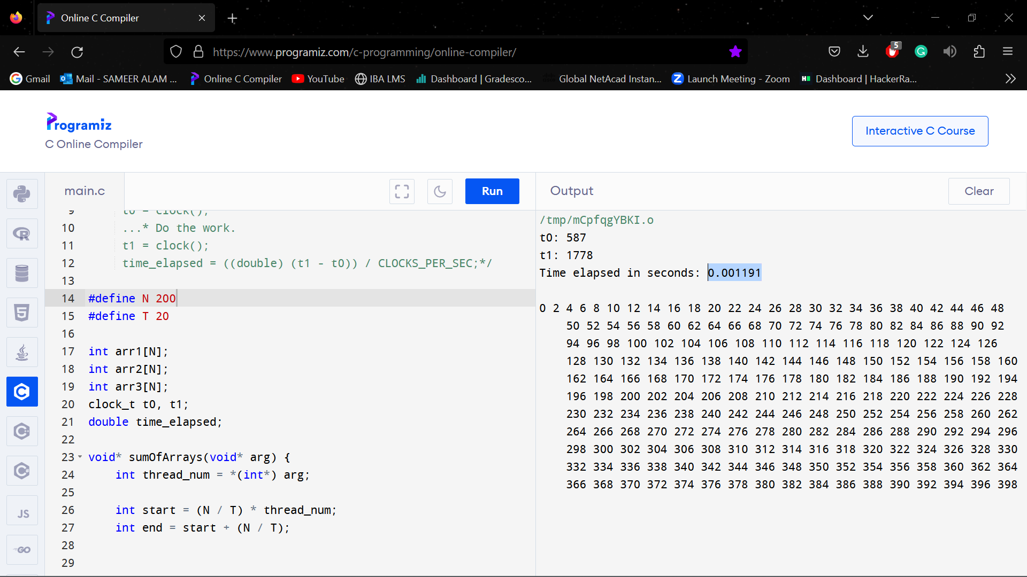

**N = 250, T = 20**

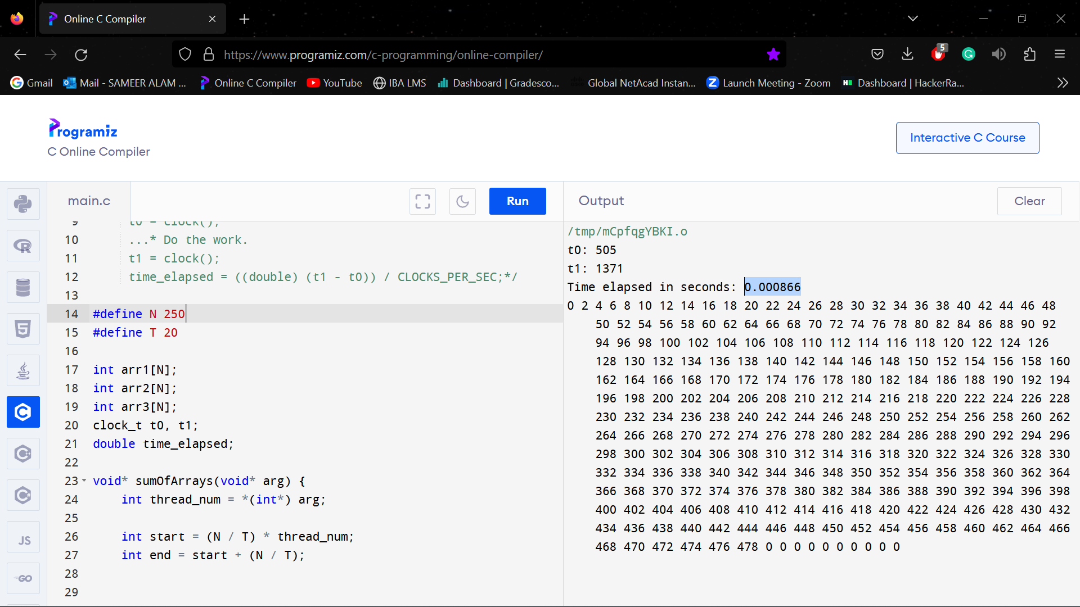

**N = 300, T = 20**

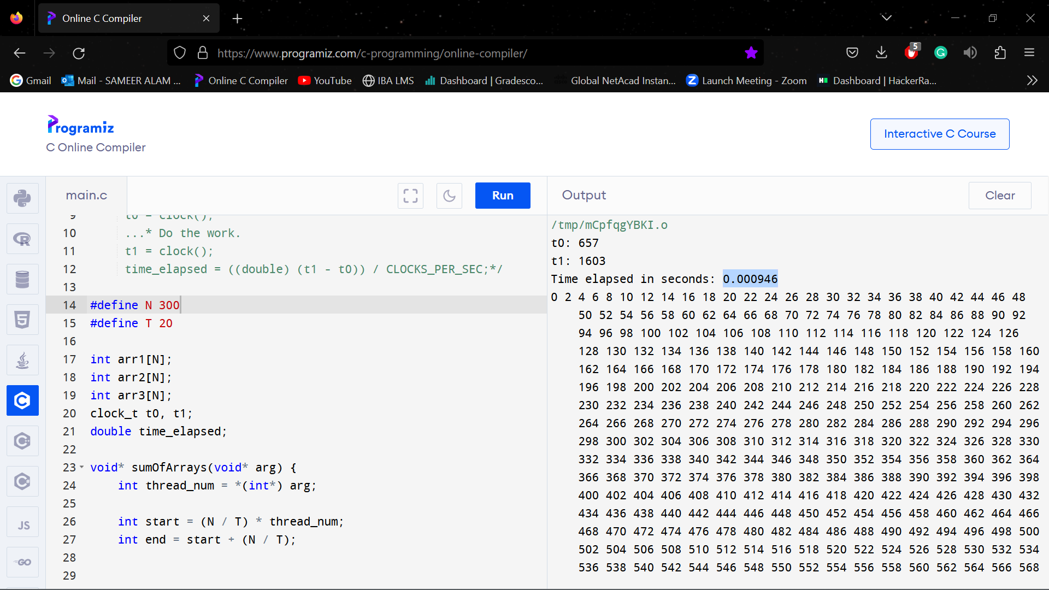

**N = 350, T = 20**

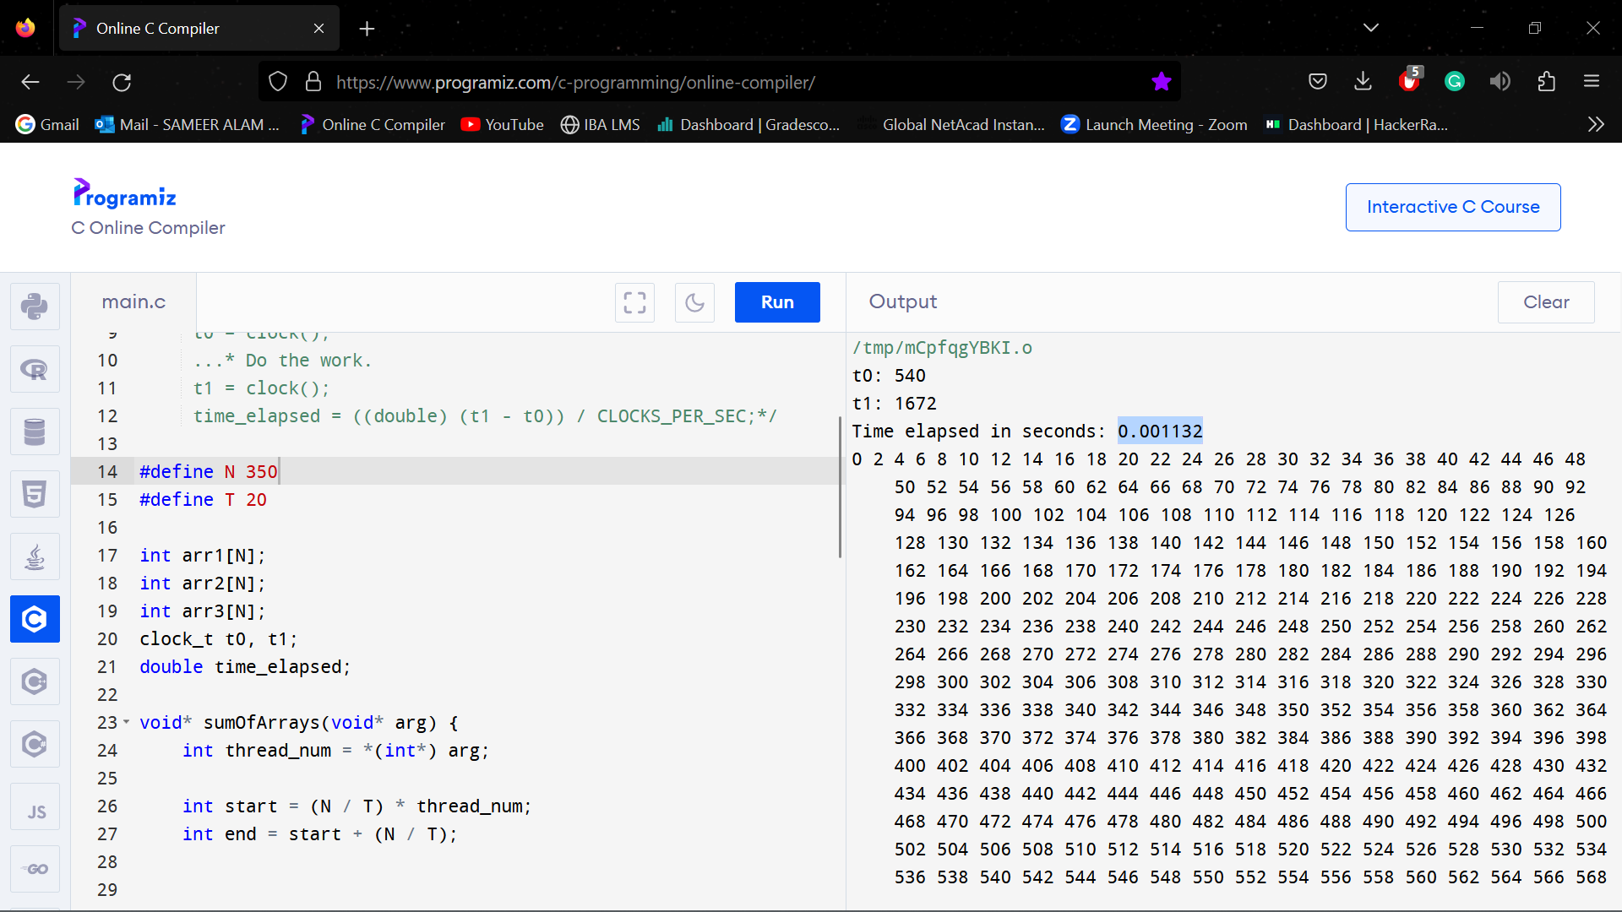

**N = 400, T = 20**

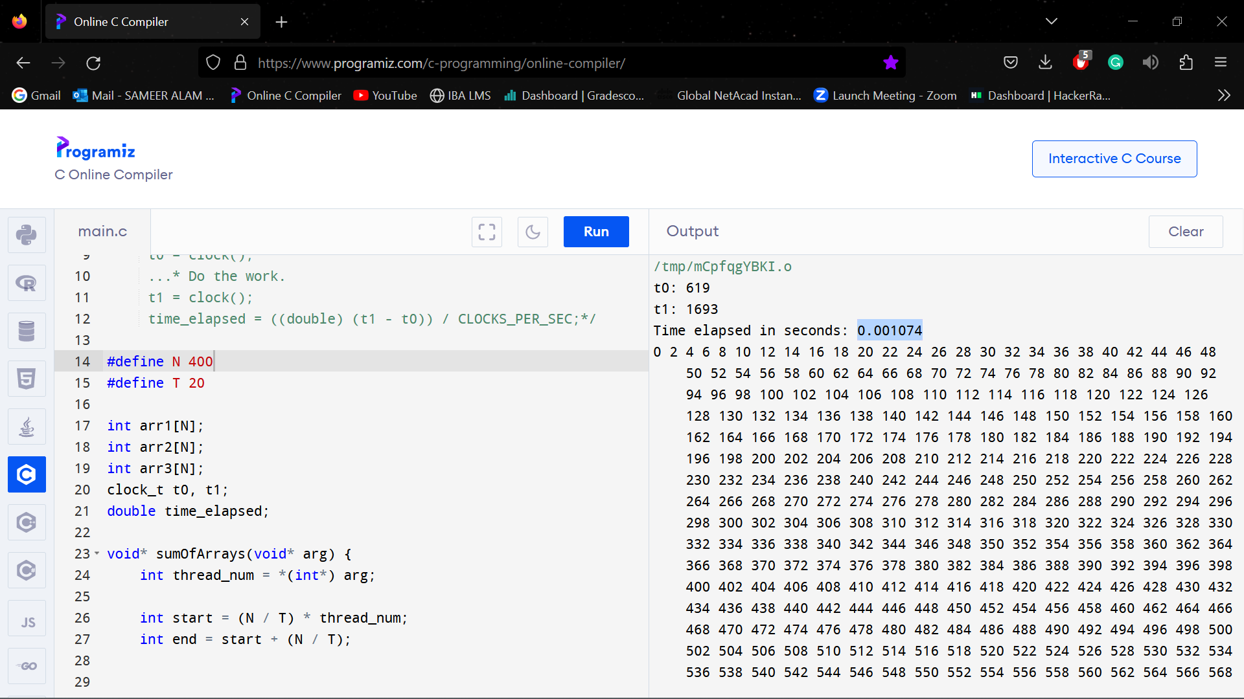

**N = 50, T = 25**

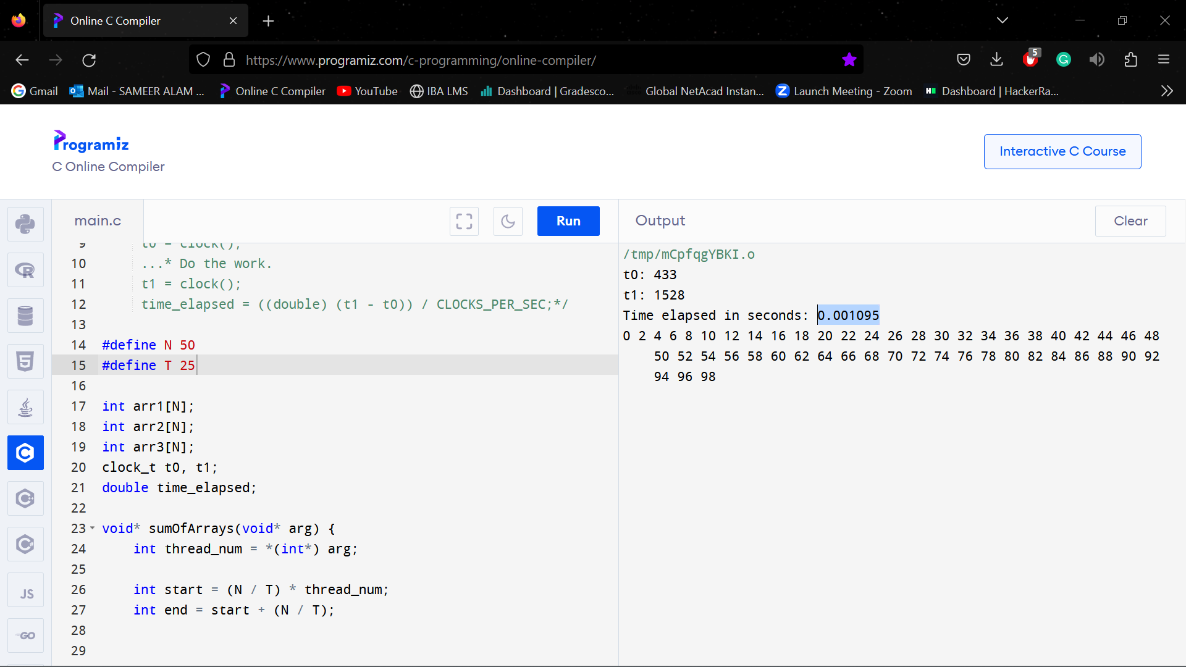

**N = 100, T = 25**

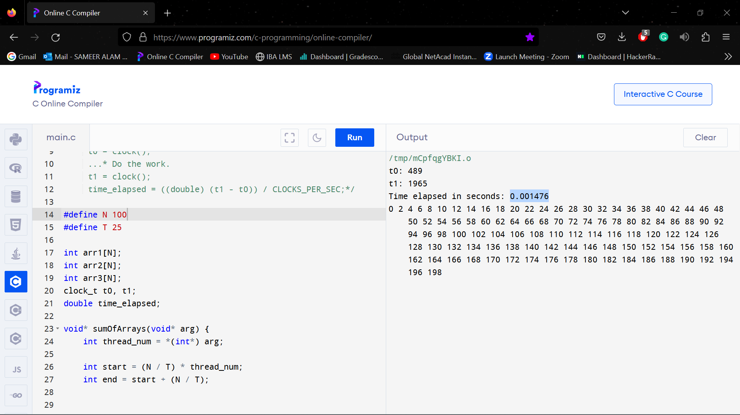

**N = 150, T = 25**

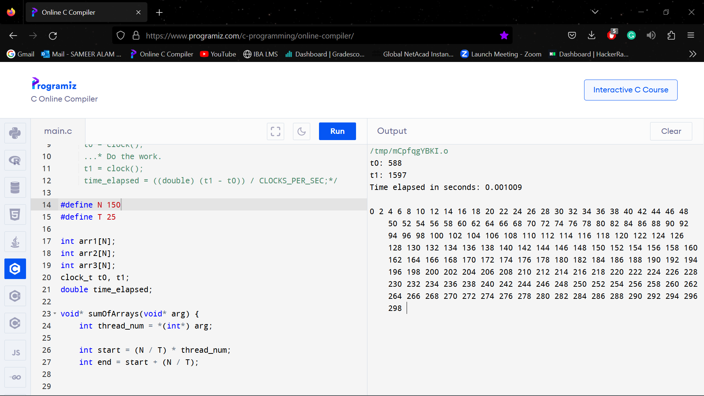

**N = 200, T = 25**

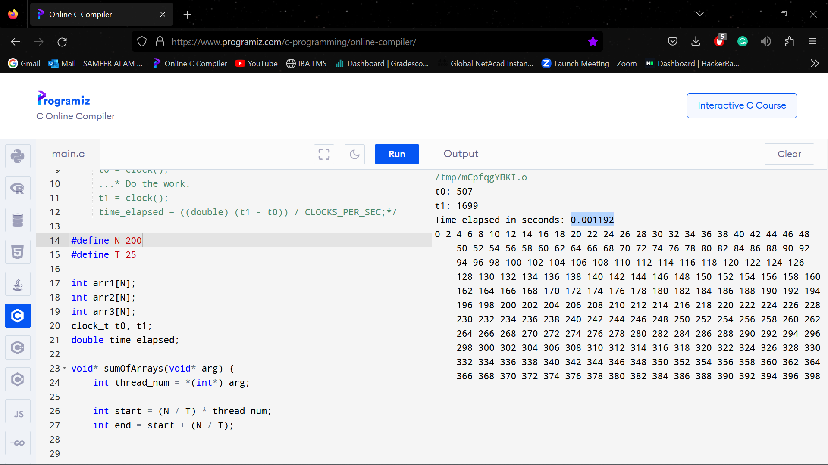

**N = 250, T = 25**

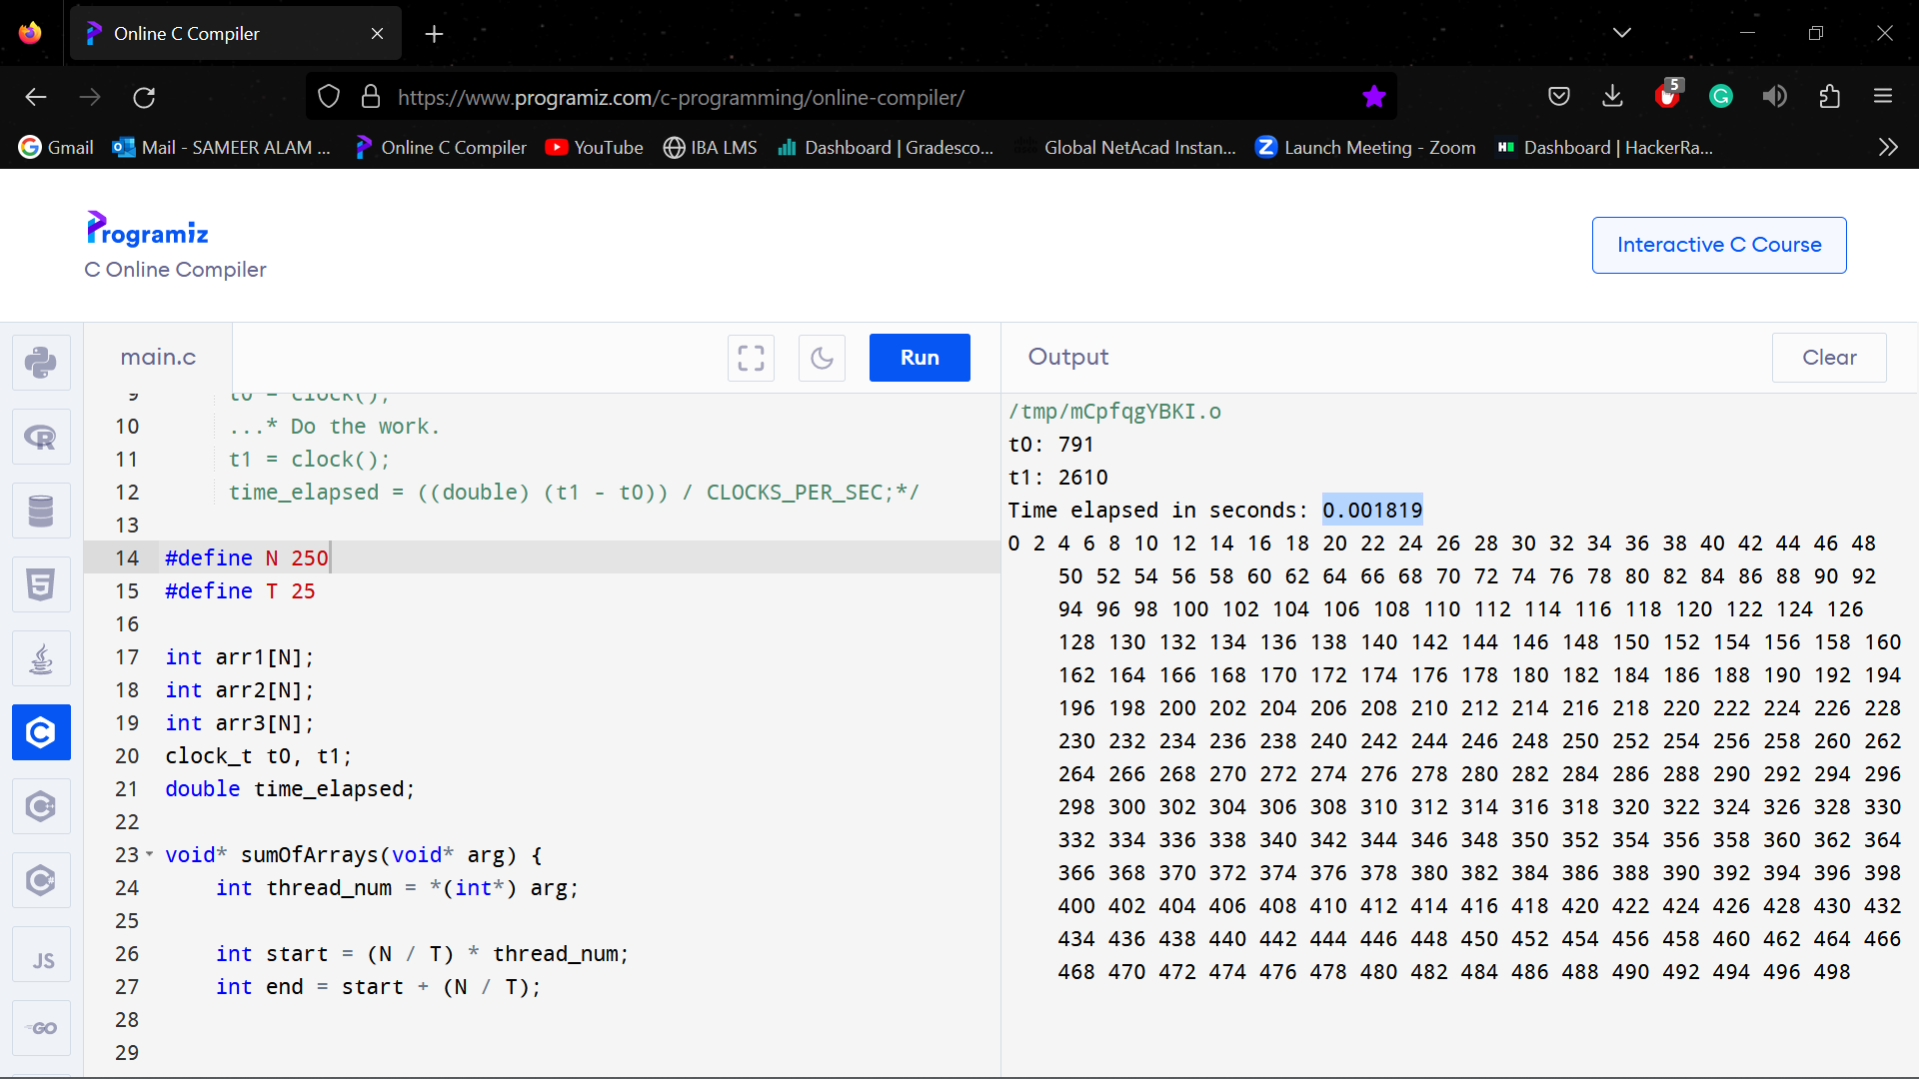

**N = 300, T = 25**

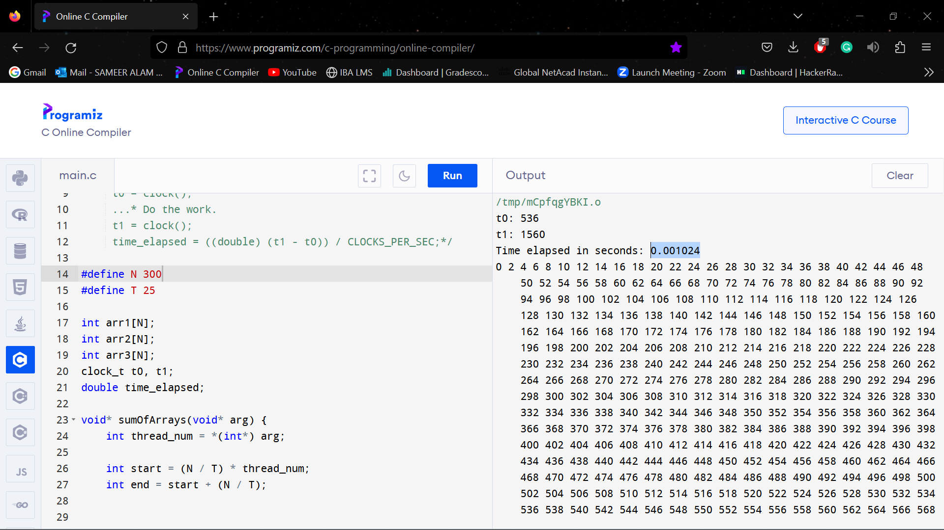

**N = 350, T = 25**

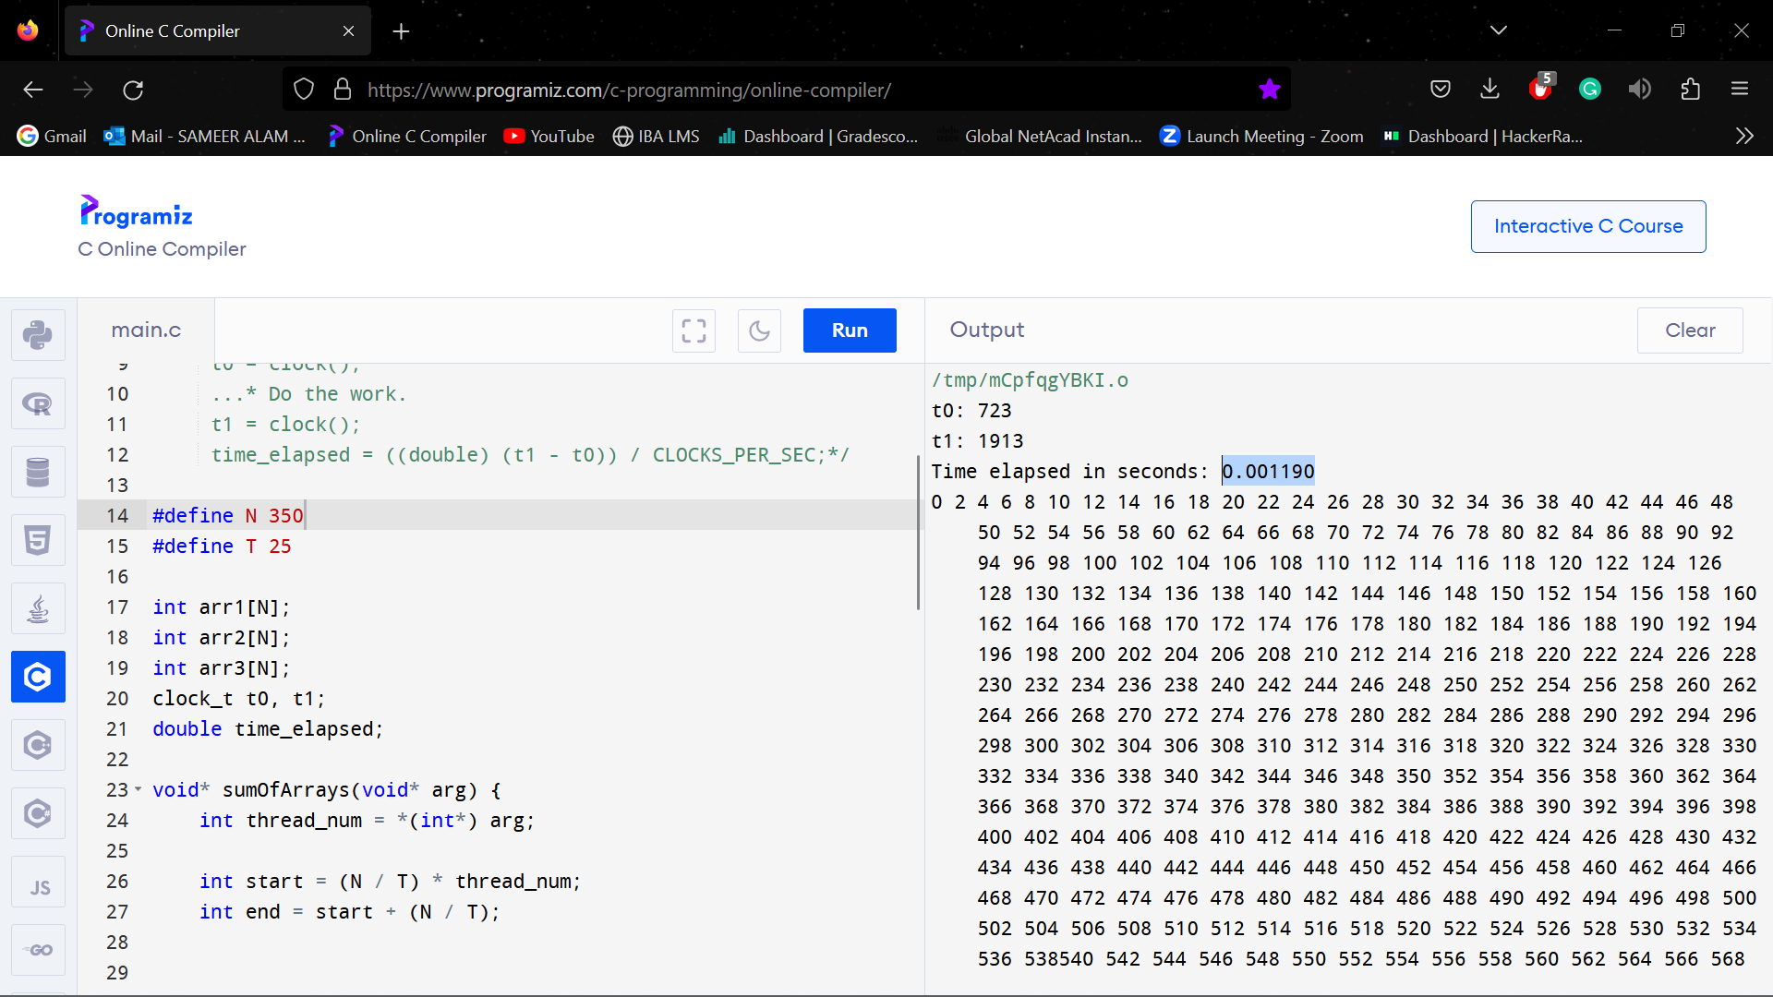

**N = 400, T = 25**

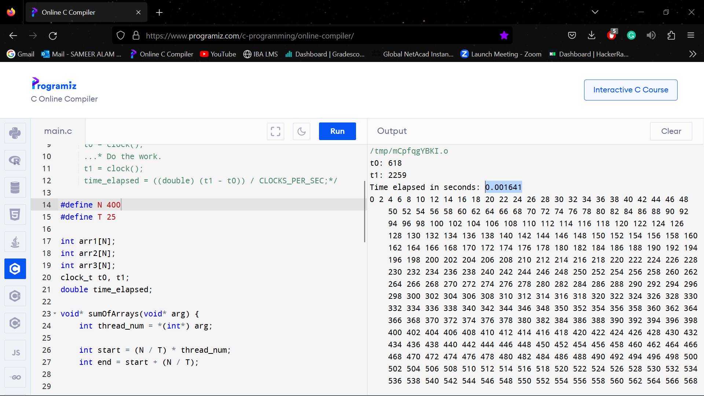

**N = 50, T = 30**

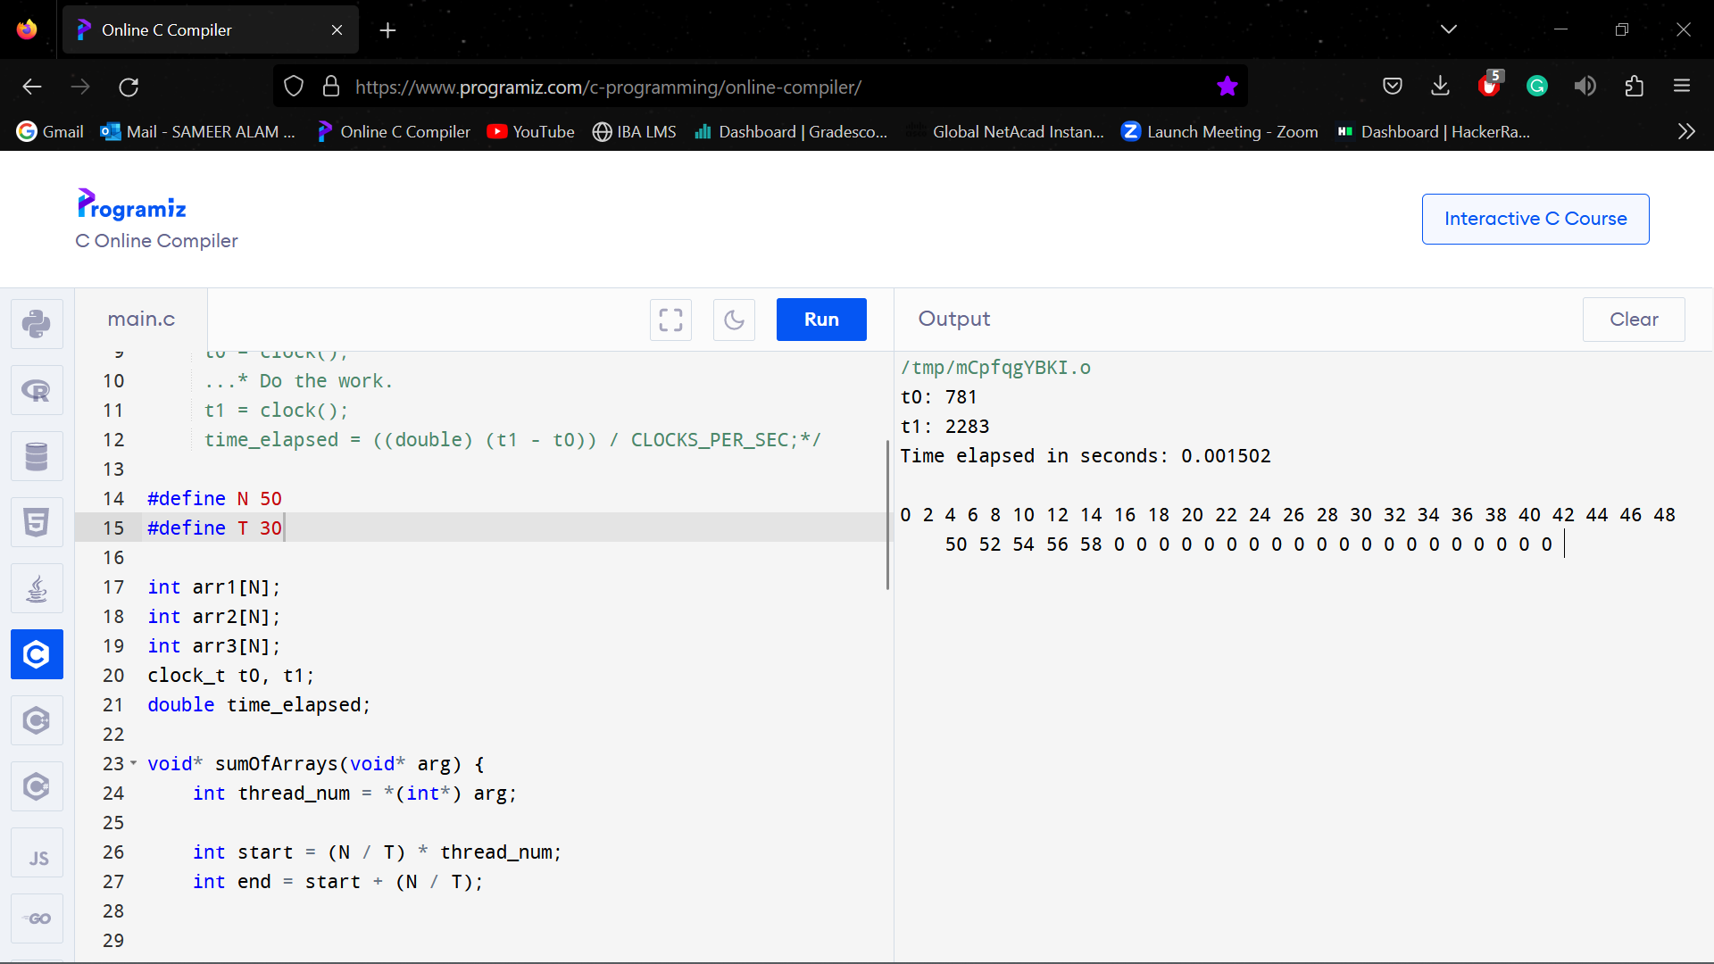

**N = 100, T = 30**

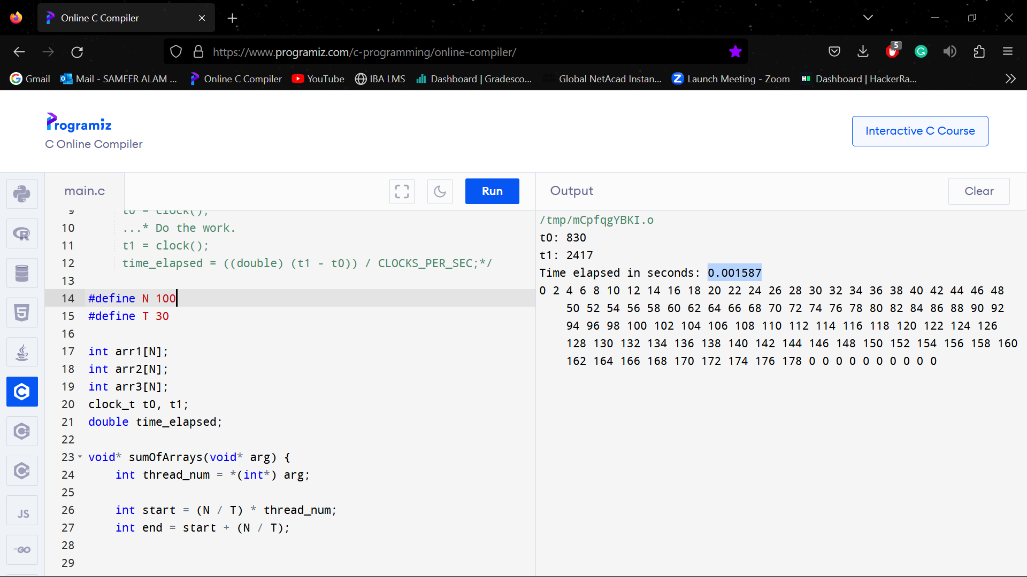

**N = 150, T = 30**

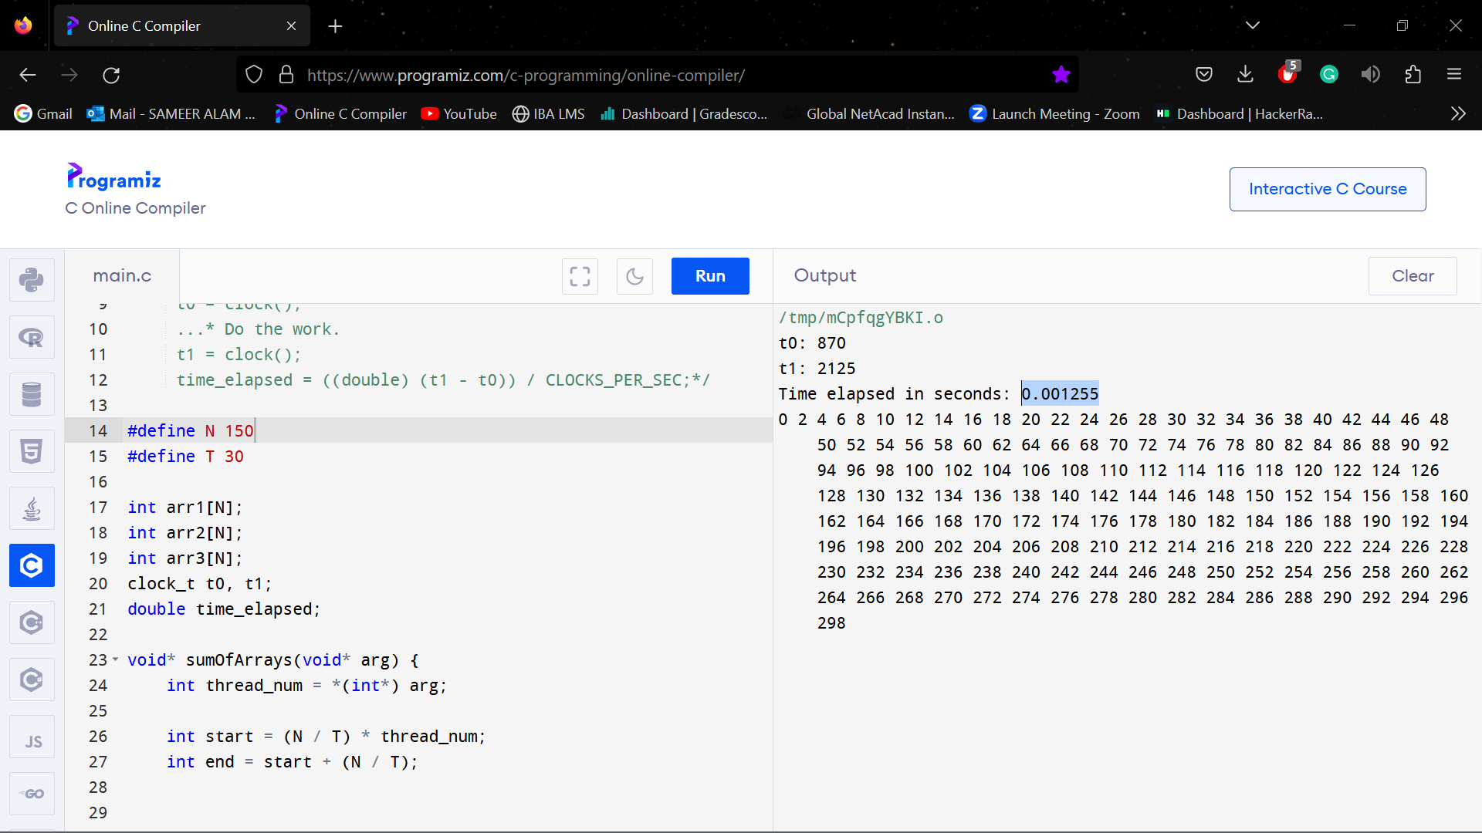

**N = 200, T = 30**

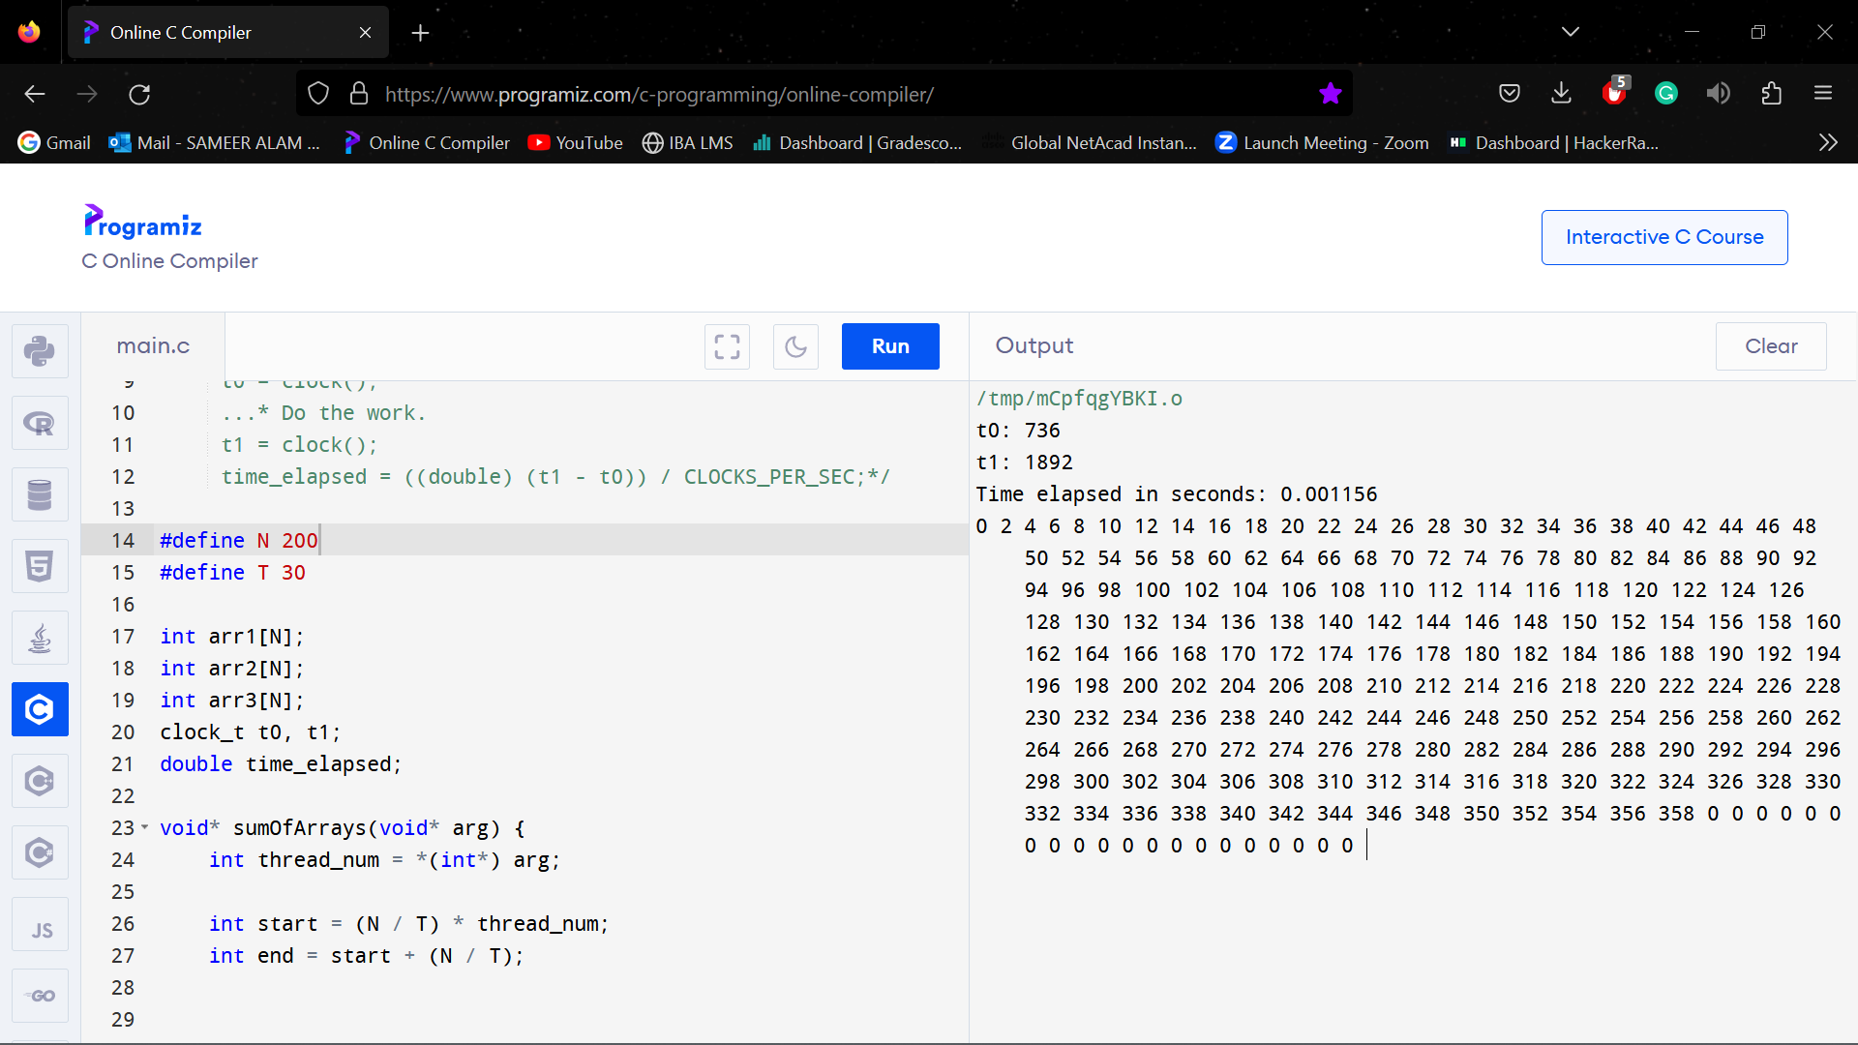

**N = 250, T = 30**

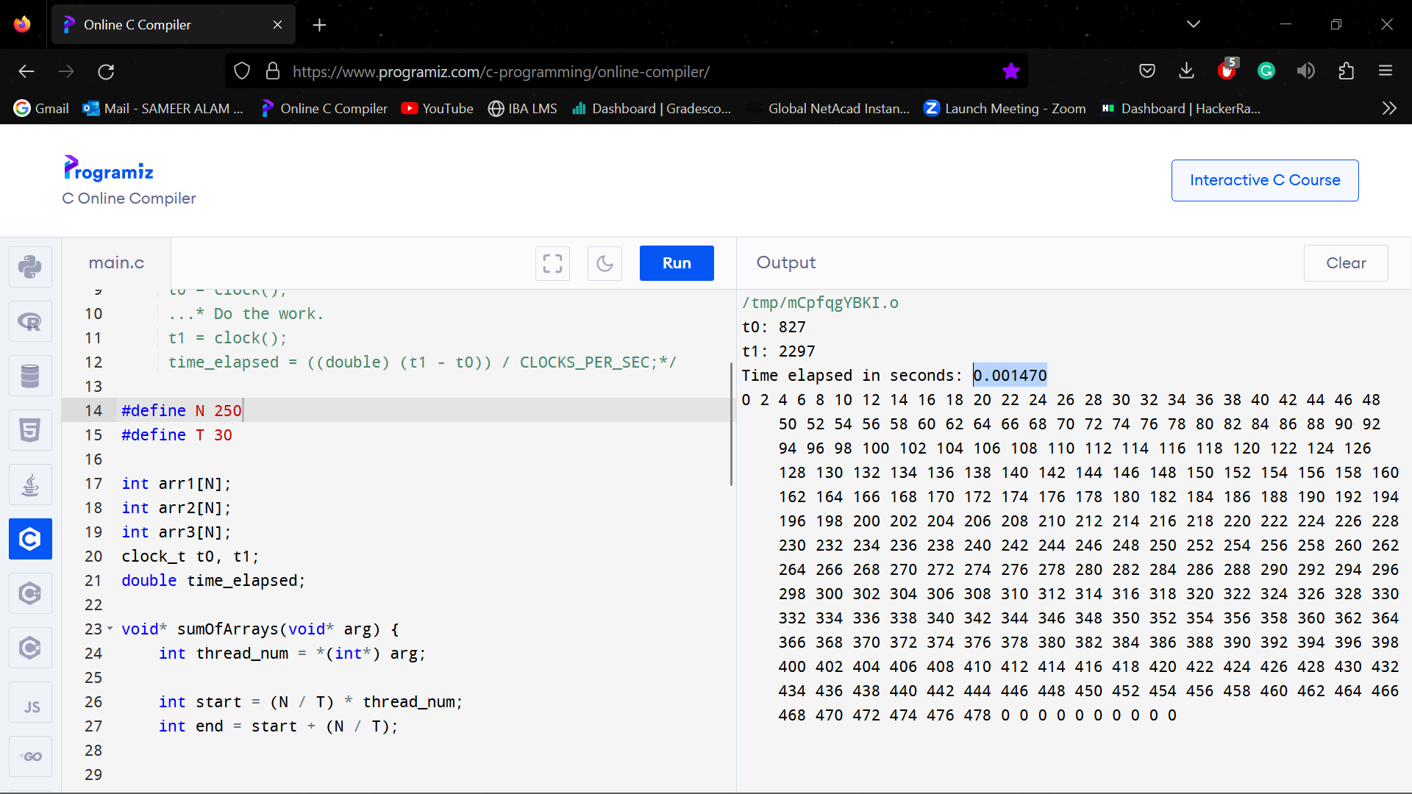

**N = 300, T = 30**

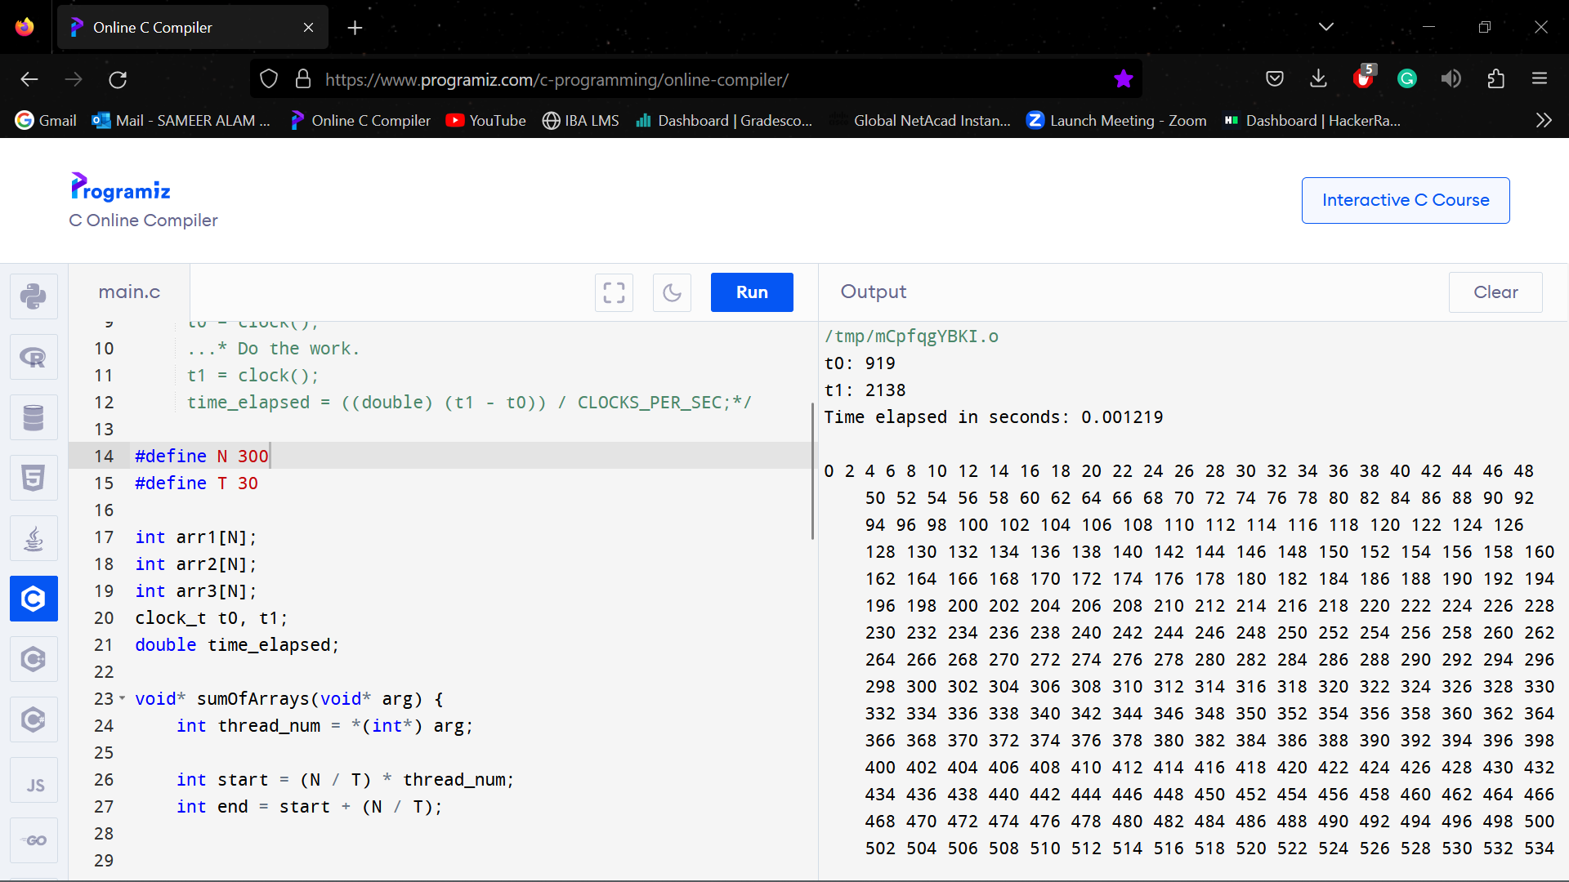

**N = 350, T = 30**

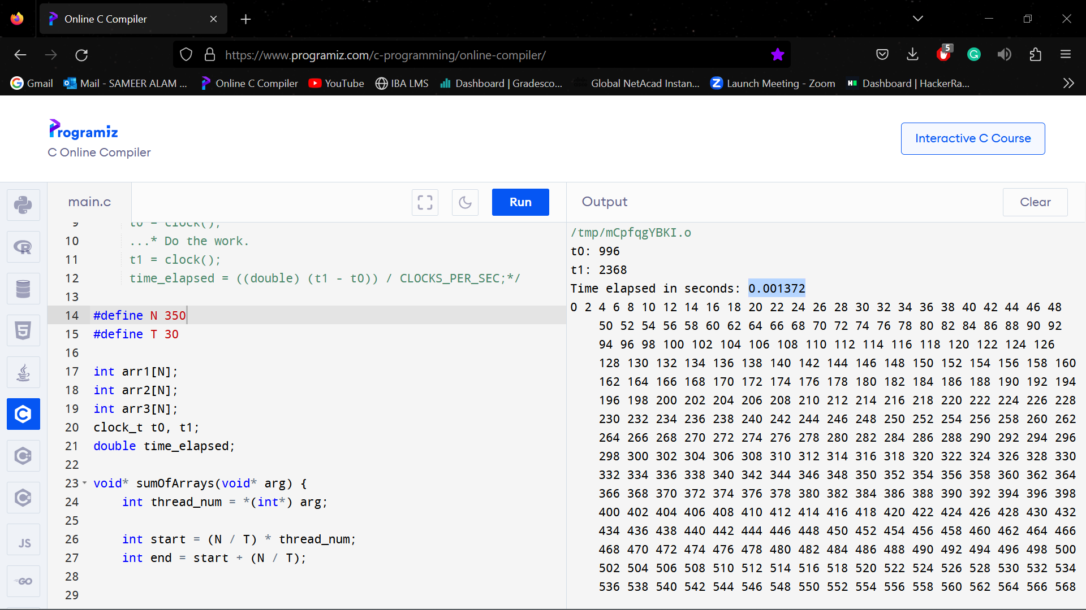

**N = 400, T = 30**

